**Data Mining Lab Book**

**Name:-** Tanmay Kamlakar Shingde  
**PRN:-** 22610059 **Class:** Final Year-IT-Sem I (2025-2026)

|  |  |  |
| --- | --- | --- |
| **Sr. No** | **Title** | **Page No.** |
| 1 | Study and use of different types of graphs and charts |  |
| 2 | Perform Normalization of data |  |
| 3 | Perform OLAP operations |  |
| 4 | Find the t and d weight of the data |  |
| 5 | Find 5 no summary of a dataset. |  |
| 6 | Using Apriori algorithm find Frequent items sets and Association rules |  |
| 7 | Find correlation between items/entities |  |
| 8 | Implement different types of clustering |  |
| 9 | Attribute for classification A. Gain B. Gini index |  |
| 10 | Write a program for Bayes Classification |  |
| 11 | Write a program to find linear regression coefficients |  |

**Aim :**Study and use of different types of graphs and charts (using MS-Excel)

**1. Line Chart**

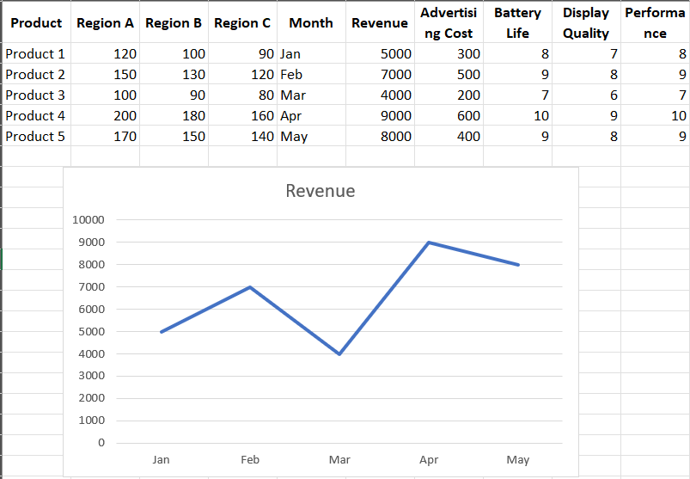

**2. Column Chart**  
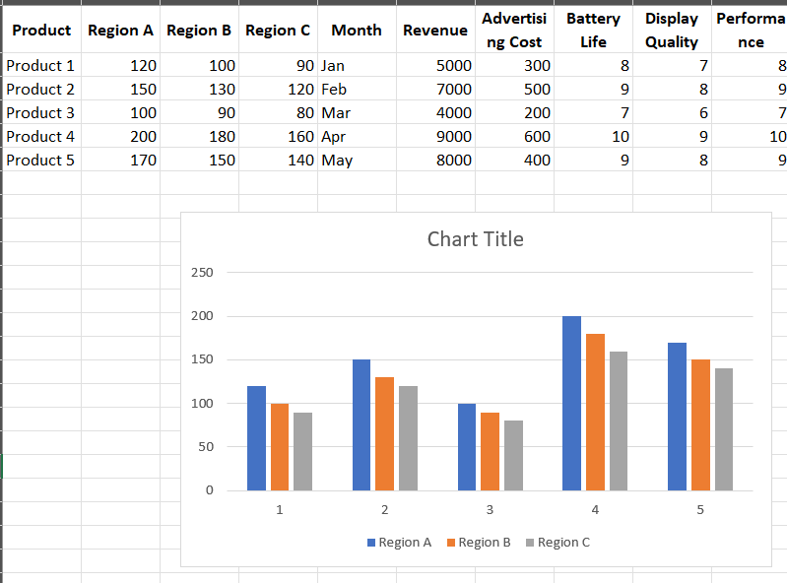

**3. Pie Chart**   
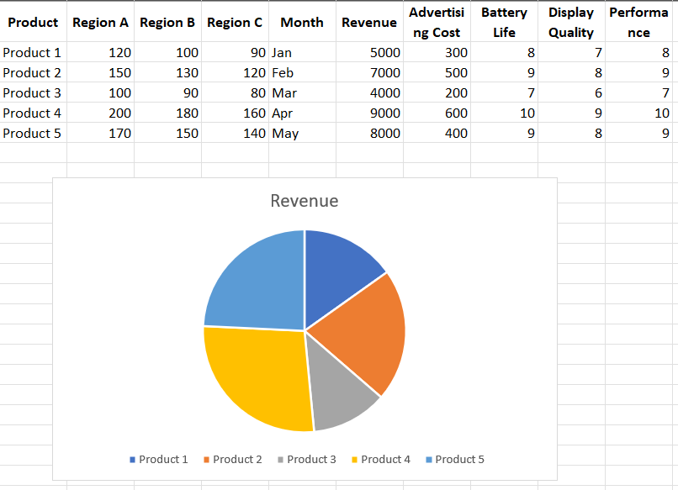

**4. Scatter Chart**  
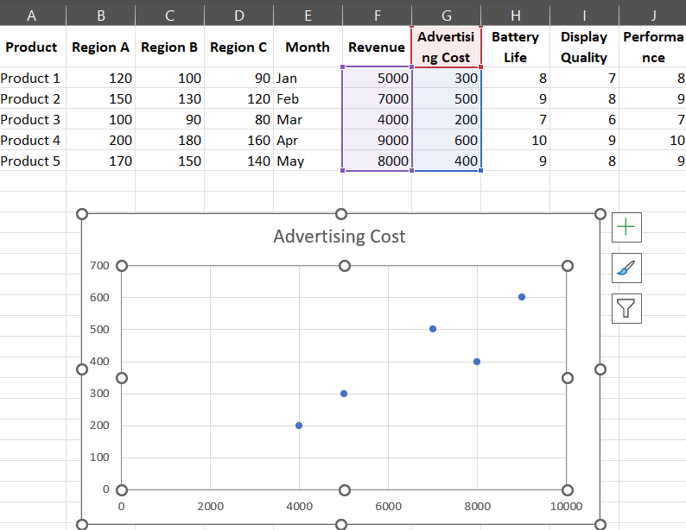

**5. Area Chart**

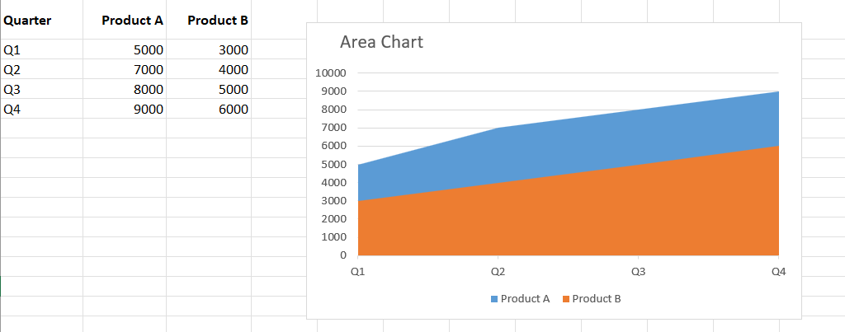

**Aim:**To perform normalization of data using decimal scaling, z-score normalization and min-max normalization.

**1) Using Program**

**Code :**

import csv

import math

def tokenize(line, delimiter=','):

    return line.strip().split(delimiter)

def normalize_decimal(value, factor):

    return value / (10 ** factor)

def normalize_zscore(value, mean, stddev):

    if stddev == 0:

        return 0

    return (value - mean) / stddev

def normalize_minmax(value, old_min, old_max, new_min, new_max):

    if old_max == old_min:

        return new_min

    return ((value - old_min) / (old_max - old_min)) * (new_max - new_min) + new_min

input_file = "data.csv"

try:

    with open(input_file, 'r') as f:

        reader = csv.reader(f)

        header = next(reader)

        rows = [row for row in reader if len(row) == len(header)]

except FileNotFoundError:

    print("Error: Could not open input file.")

    exit(1)

cols = len(header)

numeric = [[] for _ in range(cols)]

for row in rows:

    for i in range(cols):

        try:

            numeric[i].append(float(row[i]))

        except ValueError:

            pass

print("Choose normalization method:")

print("1. Decimal Scaling\n2. Z-Score Normalization\n3. Min-Max Normalization")

choice = int(input("Enter choice: "))

new_min, new_max = 0, 1

if choice == 3:

    new_min = float(input("Enter new Min: "))

    new_max = float(input("Enter new Max: "))

if choice == 1:

    output_file = "out_decimal.csv"

elif choice == 2:

    output_file = "out_zscore.csv"

elif choice == 3:

    output_file = "out_minmax.csv"

else:

    print("Invalid option!")

    exit(1)

min_val = [float('inf')] * cols

max_val = [float('-inf')] * cols

mean = [0] * cols

stddev = [0] * cols

scale_factor = [0] * cols

for i in range(cols):

    if not numeric[i]:

        continue

    min_val[i] = min(numeric[i])

    max_val[i] = max(numeric[i])

    mean[i] = sum(numeric[i]) / len(numeric[i])

    stddev[i] = math.sqrt(

        sum((v - mean[i]) ** 2 for v in numeric[i]) / len(numeric[i]))

    max_abs = max(abs(v) for v in numeric[i])

    while max_abs / (10 ** scale_factor[i]) >= 1:

        scale_factor[i] += 1

with open(output_file, 'w', newline='') as f:

    writer = csv.writer(f)

    writer.writerow(header)

    for row in rows:

        new_row = []

        for i in range(cols):

            try:

                val = float(row[i])

                if choice == 1:

                    norm = normalize_decimal(val, scale_factor[i])

                elif choice == 2:

                    norm = normalize_zscore(val, mean[i], stddev[i])

                elif choice == 3:

                    norm = normalize_minmax(

                        val, min_val[i], max_val[i], new_min, new_max)

                new_row.append(round(norm, 4))

            except ValueError:

                new_row.append(row[i])

        writer.writerow(new_row)

print(f"Normalization complete. Output written to {output_file}")

**Input :**

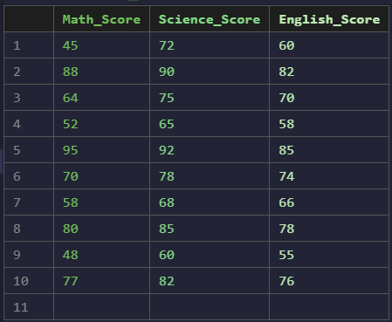

**Output :**

**Decimal Scaling Normalization  
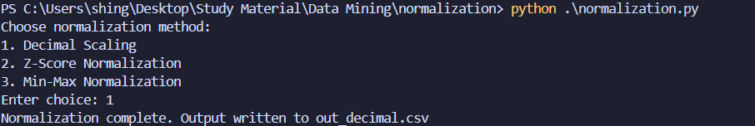**

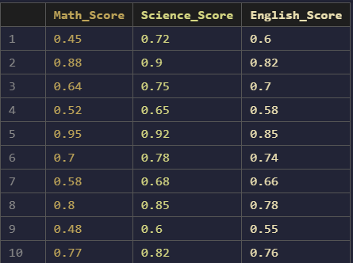

**Z-Score Normalization  
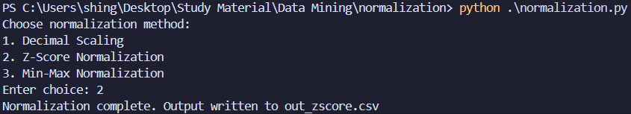**

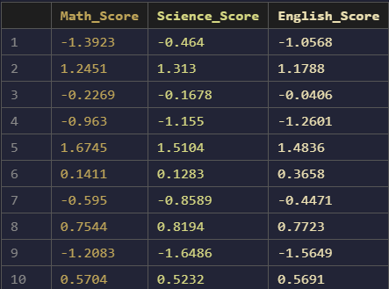

**Min-Max Normalization  
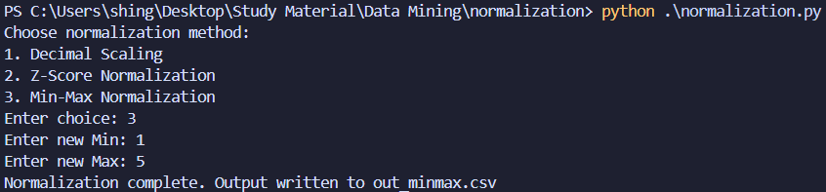  
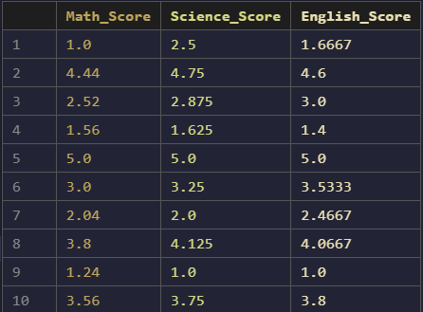**

**2) Using Knime**

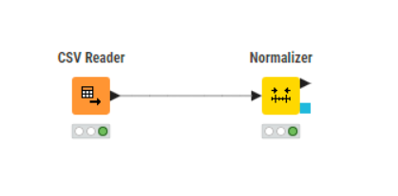

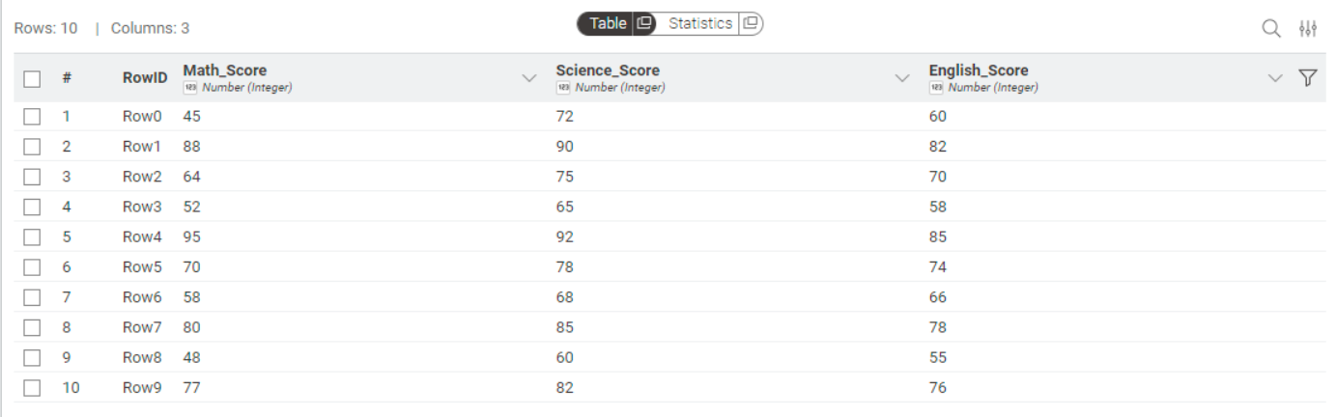

**Min-Max Normalization**

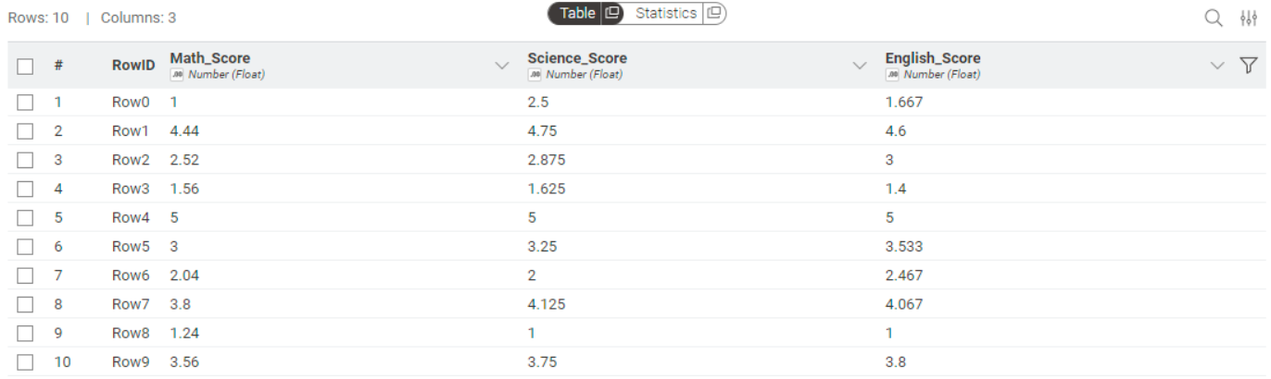

**Decimal Scaling Normalization  
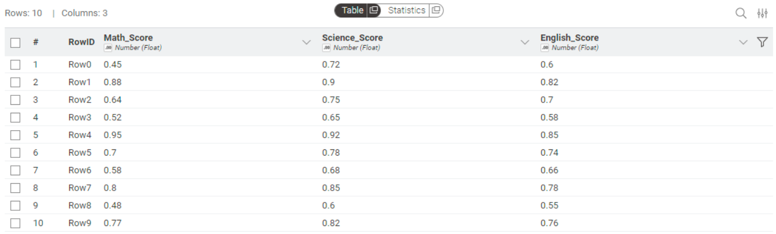**

**Z-Score Normalization  
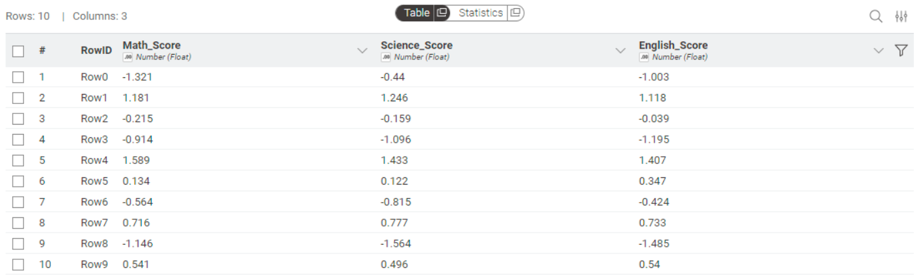**

**Aim:**To implement and understand OLAP (online analytical processing) and perform various operations such as cube, roll-up, drill-down, slice and dice on multidimensional data.

**Code:**

import pandas as pd

import itertools

import os

from collections import defaultdict

def read_data(filename='data.csv'):

df = pd.read_csv(filename)

print(f"Columns in data: {list(df.columns)}")

measure = input("Enter target (measure) column name: ").strip()

if measure not in df.columns:

raise RuntimeError(f"Column '{measure}' not found in data.")

dims = [c for c in df.columns if c != measure]

for d in dims:

df[d] = df[d].astype(str)

return df, dims, measure

def all_subsets(seq):

items = list(seq)

for r in range(len(items)+1):

for comb in itertools.combinations(items, r):

yield comb

def build_olap_cube(df, dims, measure, fill_value='ALL'):

cube_rows = []

records = df.to_dict(orient='records')

rec_values = [tuple(rec[d] for d in dims) + (rec[measure],) for rec in records]

for subset in all_subsets(dims):

if len(subset) == 0:

total = sum(rv[-1] for rv in rec_values)

row = {d: fill_value for d in dims}

row[measure] = total

cube_rows.append(row)

continue

idxs = [dims.index(s) for s in subset]

agg = defaultdict(float)

for rv in rec_values:

key = tuple(rv[i] for i in idxs)

agg[key] += rv[-1]

for key, val in agg.items():

row = {}

for d in dims:

if d in subset:

pos = subset.index(d)

row[d] = key[pos]

else:

row[d] = fill_value

row[measure] = val

cube_rows.append(row)

cube_df = pd.DataFrame(cube_rows)

cube_df = cube_df[dims + [measure]]

cube_df = cube_df.sort_values(by=dims).reset_index(drop=True)

return cube_df

def roll_up(cube_df, dims, measure, target_dims):

mask = pd.Series(True, index=cube_df.index)

for d in dims:

if d not in target_dims:

mask &= (cube_df[d] == 'ALL')

res = cube_df[mask][target_dims + [measure]].drop_duplicates().reset_index(drop=True)

return res

def drill_down(cube_df, dims, measure, drill_dims):

mask = pd.Series(True, index=cube_df.index)

for d in drill_dims:

mask &= (cube_df[d] != 'ALL')

res = cube_df[mask][drill_dims + [measure]].drop_duplicates().reset_index(drop=True)

return res

def slice_cube(cube_df, dims, measure, slice_dim, value):

res = cube_df[cube_df[slice_dim] == str(value)][dims + [measure]].reset_index(drop=True)

return res

def dice_cube(cube_df, dims, measure, filters):

mask = pd.Series(True, index=cube_df.index)

for d, v in filters.items():

if isinstance(v, (list, tuple, set)):

mask &= cube_df[d].isin([str(x) for x in v])

else:

mask &= (cube_df[d] == str(v))

res = cube_df[mask][dims + [measure]].reset_index(drop=True)

return res

def print_menu(dims, measure):

print("\nChoose an operation to perform on the cube:")

print("1. Show full cube")

print("2. Roll-up (aggregate to target dims)")

print("3. Drill-down (show detailed levels)")

print("4. Slice (fix one dimension)")

print("5. Dice (filter multiple dimensions)")

print("6. Exit\n")

print(f"Available dimensions: {dims}, measure: {measure}")

def interactive_cli(cube_df, dims, measure):

import sys

if not sys.stdin.isatty():

print("\nInteractive mode skipped (stdin is not a TTY). Run the script in a terminal for interactive queries.")

return

while True:

print_menu(dims, measure)

choice = input("Enter choice (1-6): ").strip()

if choice == '1':

print("\nFull Cube:")

print(cube_df.to_string(index=False))

elif choice == '2':

td = input(f"Enter target dimensions for roll-up separated by commas (subset of {dims}): ").strip()

target_dims = [x.strip() for x in td.split(',') if x.strip()]

invalid = [d for d in target_dims if d not in dims]

if invalid:

print("Invalid dimensions:", invalid)

continue

res = roll_up(cube_df, dims, measure, target_dims)

print("\nRoll-up result:")

print(res.to_string(index=False))

elif choice == '3':

dd = input(f"Enter dimensions for drill-down separated by commas (e.g. Month,Product): ").strip()

drill_dims = [x.strip() for x in dd.split(',') if x.strip()]

invalid = [d for d in drill_dims if d not in dims]

if invalid:

print("Invalid dimensions:", invalid)

continue

res = drill_down(cube_df, dims, measure, drill_dims)

print("\nDrill-down result:")

print(res.to_string(index=False))

elif choice == '4':

sd = input(f"Enter slice dimension (one of {dims}): ").strip()

if sd not in dims:

print("Invalid dimension.")

continue

val = input("Enter value to slice on (e.g. Feb): ").strip()

res = slice_cube(cube_df, dims, measure, sd, val)

if res.empty:

print("\nNo rows found for this slice.")

else:

print("\nSlice result:")

print(res.to_string(index=False))

elif choice == '5':

print("Enter dice filters in format Dim=Val,Dim2=Val1|Val2 (use '|' for multiple values)")

raw = input("Filters: ").strip()

try:

filters = {}

parts = [p.strip() for p in raw.split(',') if p.strip()]

for p in parts:

if '=' not in p:

raise ValueError("Invalid format")

k,v = p.split('=',1)

k = k.strip()

v = v.strip()

if k not in dims:

raise ValueError(f"Unknown dimension {k}")

if '|' in v:

vals = [x.strip() for x in v.split('|') if x.strip()]

filters[k] = vals

else:

filters[k] = v

res = dice_cube(cube_df, dims, measure, filters)

if res.empty:

print("\nNo rows found for these dice filters.")

else:

print("\nDice result:")

print(res.to_string(index=False))

except Exception as e:

print("Error parsing filters:", e)

elif choice == '6':

print("Exiting.")

break

else:

print("Invalid choice. Try again.")

def main():

df, dims, measure = read_data()

print("\nInput Data:")

print(df.to_string(index=False))

cube_df = build_olap_cube(df, dims, measure)

print("\nGenerated OLAP Cube:")

print(cube_df.to_string(index=False))

cube_df.to_csv('cube_output.csv', index=False)

print("\nCube saved to: cube_output.csv")

interactive_cli(cube_df, dims, measure)

if __name__ == "__main__":

main()

**Input :**

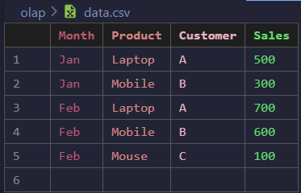

**Ouput:  
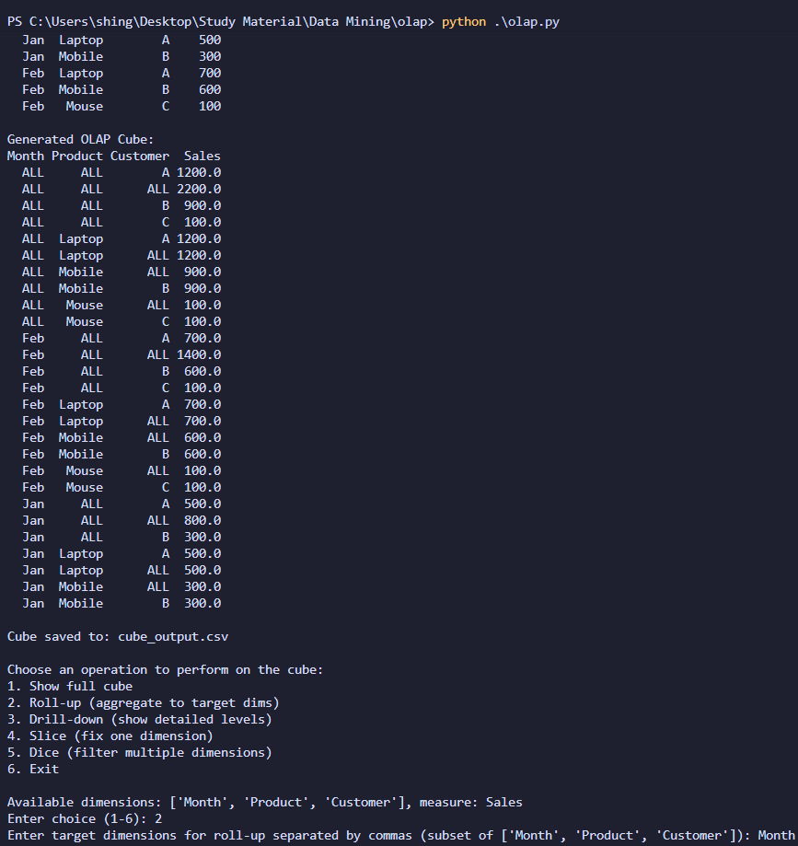  
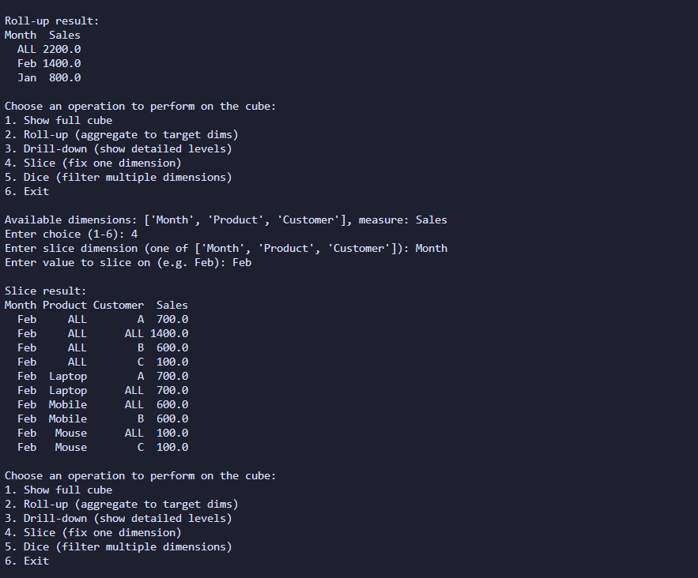**

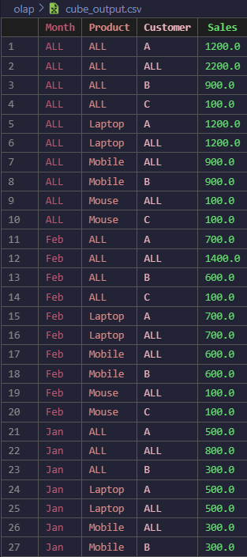

**Aim :**Find T-weight and D-weight of a data

**Code :**import csv

with open("data.csv", "r") as f:

    reader = csv.reader(f)

    header = next(reader)

    data = [row for row in reader]

group_cols = header[1:]

rows = []

for row in data:

    class_name = row[0]

    values = list(map(int, row[1:]))

    total = sum(values)

    rows.append([class_name] + values + [total])

totals = [sum(col) for col in zip(*[r[1:] for r in rows])]

total_per_class = [r[-1] for r in rows]

out_header = header + ["TOTAL"]

for col in group_cols:

    out_header.append(f"T-weight ({col})")

    out_header.append(f"D-weight ({col})")

out_rows = []

for r in rows:

    class_name = r[0]

    values = r[1:-1]

    total = r[-1]

    new_row = [class_name] + values + [total]

    for i, col in enumerate(group_cols):

        new_row.append(values[i] / totals[i])

        new_row.append(values[i] / total)

    out_rows.append(new_row)

print("\n=== Generalized T-weight & D-weight Table ===\n")

print(out_header)

for r in out_rows:

    print(r)

with open("output_weights.csv", "w", newline="") as f:

    writer = csv.writer(f)

    writer.writerow(out_header)

    writer.writerows(out_rows)

**Input:**

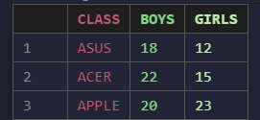

**Output:  
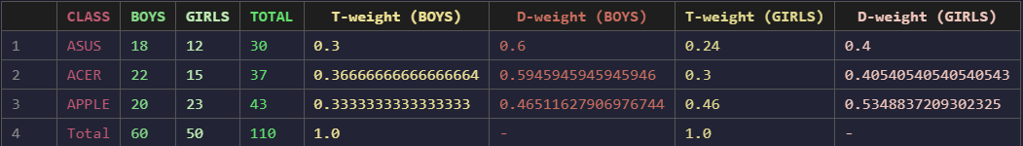**

**Aim :**Find 5 Number Summary of a Dataset

**1) Using Program**  
**Code :**import csv

import matplotlib.pyplot as plt

data = []

with open("data.csv", "r") as file:

    reader = csv.reader(file)

    next(reader)

    for row in reader:

        if row:

            data.append(float(row[0]))

data.sort()

n = len(data)

def median(values):

    m = len(values)

    mid = m // 2

    if m % 2 == 0:

        return (values[mid - 1] + values[mid]) / 2

    else:

        return values[mid]

minimum = data[0]

maximum = data[-1]

q2 = median(data)

if n % 2 == 0:

    lower_half = data[:n//2]

    upper_half = data[n//2:]

else:

    lower_half = data[:n//2]

    upper_half = data[n//2+1:]

q1 = median(lower_half)

q3 = median(upper_half)

print("=== Five Number Summary ===")

print(f"Minimum     : {minimum}")

print(f"Q1 (25%)    : {q1}")

print(f"Median (Q2) : {q2}")

print(f"Q3 (75%)    : {q3}")

print(f"Maximum     : {maximum}")

plt.boxplot(data)

plt.title("Box Plot - Five Number Summary")

plt.xlabel("Values")

plt.show()

**Input:**

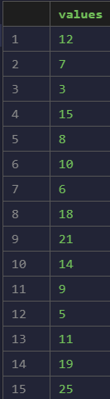

**Ouput:**

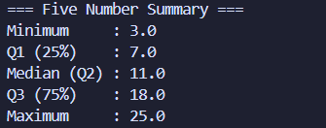

**Box Plot:**

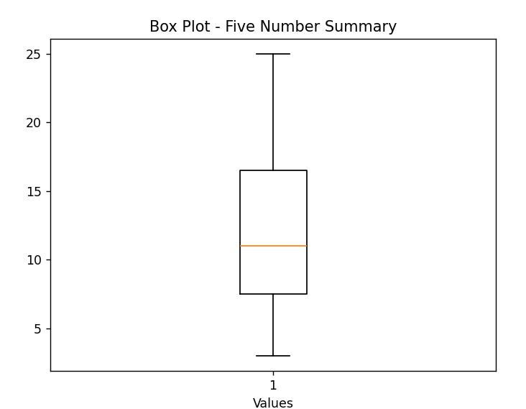

**Aim :**To implement the Apriori algorithm, find frequent itemsets for a transactional dataset, and generate association rules

**1)** **Using Program**

**Code :**import pandas as pd

df = pd.read_csv('data.csv')

def parse_data(df):

    transactions = []

    for i in range(len(df)):

        row = df.iloc[i]

        transaction = []

        for item in row:

            if pd.notna(item) and item.replace(' ', '') != '':

                transaction.append(str(item))

        transactions.append(transaction)

    return transactions

def apriori(transactions, min_support):

    if not (0 < min_support <= 1):

        raise ValueError("min_support must be between 0 and 1")

    n = len(transactions)

    min_cnt = max(1, (int)(min_support*n))

    item_cnt = {}

    for t in transactions:

        for it in t:

            if it not in item_cnt:

                item_cnt[it] = 1

            else:

                item_cnt[it] += 1

    l1 = [frozenset([it]) for it, cnt in item_cnt.items() if cnt >= min_cnt]

    supports = {}

    freq_itemsets = []

    for it in l1:

        cnt = item_cnt[list(it)[0]]

        support = cnt/n

        supports[it] = support

        freq_itemsets.append((it, cnt, support))

    k = 2

    lk_1 = l1

    while len(lk_1) > 0:

        candidates = set()

        for i in range(len(lk_1)):

            for j in range(i+1, len(lk_1)):

                combined = lk_1[i] | lk_1[j]

                if len(combined) == k:

                    candidates.add(combined)

        candidates = list(candidates)

        pruned_candidates = []

        for c in candidates:

            flag = True

            for it in c:

                subset = c - frozenset([it])

                if subset not in lk_1:

                    flag = False

                    break

            if flag:

                pruned_candidates.append(c)

        candidates = pruned_candidates

        counts = {}

        for t in transactions:

            tset = frozenset(t)

            for c in candidates:

                if c.issubset(tset):

                    if c not in counts:

                        counts[c] = 1

                    else:

                        counts[c] += 1

        lk = [c for c in candidates if c in counts and counts[c] >= min_cnt]

        for it in lk:

            support = counts[it]/n

            supports[it] = support

            freq_itemsets.append((it, counts[it], support))

        lk_1 = lk

        k += 1

    return freq_itemsets, supports

def get_association_rules(freq_itemsets, min_confidence, transactions):

    rules = []

    n = len(transactions)

    for itemset, count, support in freq_itemsets:

        if len(itemset) > 1:

            for item in itemset:

                antecedent = frozenset([item])

                consequent = itemset - antecedent

                if len(consequent) > 0:

                    antecedent_count = sum(

                        1 for t in transactions if antecedent.issubset(frozenset(t)))

                    confidence = count / antecedent_count

                    if confidence >= min_confidence:

                        # lift calculation removed

                        rules.append((antecedent, consequent, confidence))

    return rules

def main():

    transactions = parse_data(df)

    print("Parsed Transactions: ")

    for transaction in transactions[0:5]:

        print(transaction)

    print("...")

    min_support = float(input("Enter minimum support (0-1): "))

    freq_itemsets, supports = apriori(transactions, min_support)

    print("\nFrequent Itemsets:")

    for itemset, count, support in freq_itemsets:

        print(

            f"Itemset: {set(itemset)}, Count: {count}, Support: {support:.4f}")

    fi_rows = []

    for itemset, count, support in freq_itemsets:

        fi_rows.append({

            "itemset": "{" + f"{','.join(sorted(list(itemset)))}" + "}",

            "count": count,

            "support": f"{support:.6f}",

        })

    pd.DataFrame(fi_rows).to_csv("frequent_itemsets.csv", index=False)

    if not freq_itemsets:

        print("No frequent itemsets found with the given minimum support.")

    else:

        print(f"Total frequent itemsets found: {len(freq_itemsets)}\n")

    min_confidence = float(input("Enter minimum confidence (0-1): "))

    rules = get_association_rules(freq_itemsets, min_confidence, transactions)

    print("\nAssociation Rules:")

    for antecedent, consequent, confidence in rules:

        print(f"Rule: {set(antecedent)} -> {set(consequent)}, "

              f"Confidence: {confidence:.4f}")

    ar_rows = []

    for antecedent, consequent, confidence in rules:

        ar_rows.append({

            "antecedent":  "{" + f"{','.join(sorted(list(antecedent)))}" + "}",

            "consequent": "{" + f"{','.join(sorted(list(consequent)))}" + "}",

            "confidence": f"{confidence:.6f}",

        })

    pd.DataFrame(ar_rows).to_csv("association_rules.csv", index=False)

    if not rules:

        print("No association rules found with the given minimum confidence.")

    else:

        print(f"Total rules found: {len(rules)}")

if __name__ == "__main__":

    main()

**Input:**

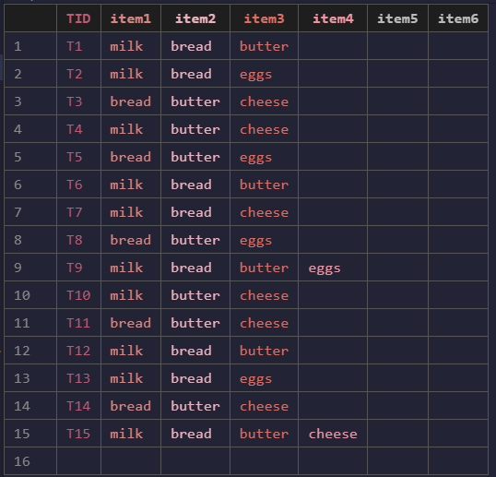

**Output:  
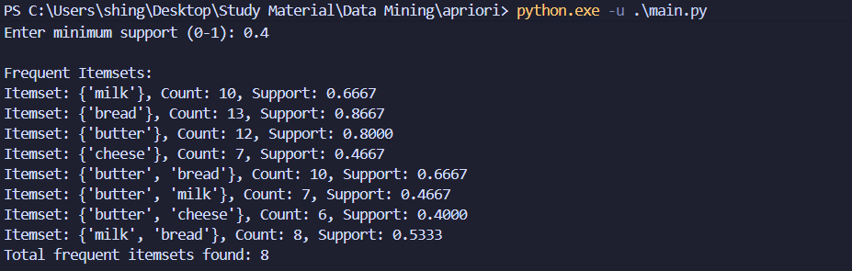  
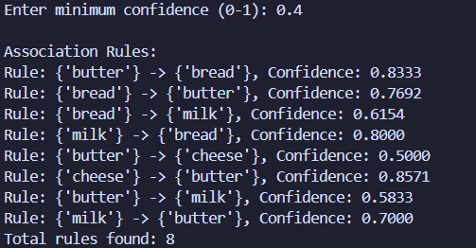  
  
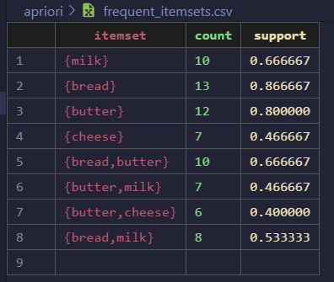**

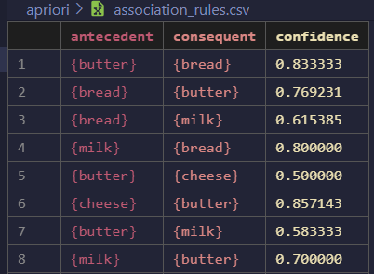

**2) Using Knime**

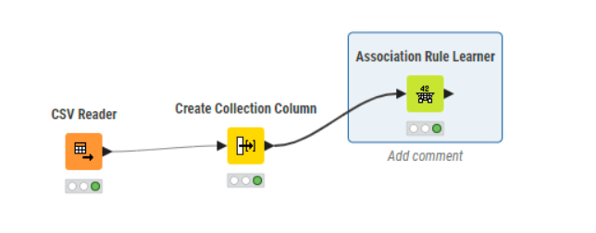

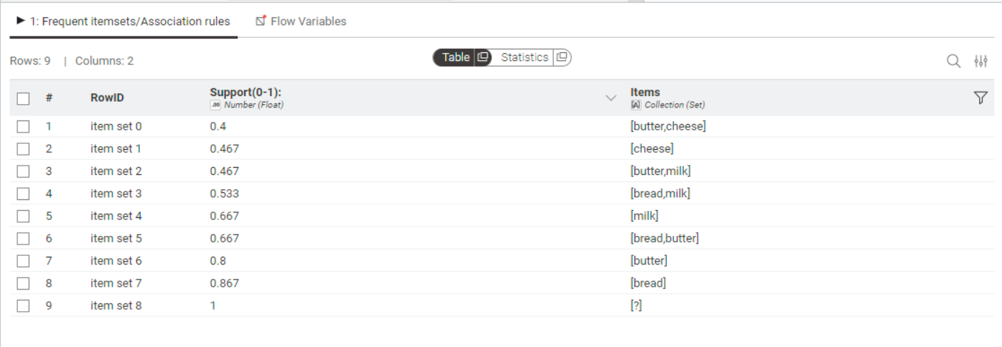

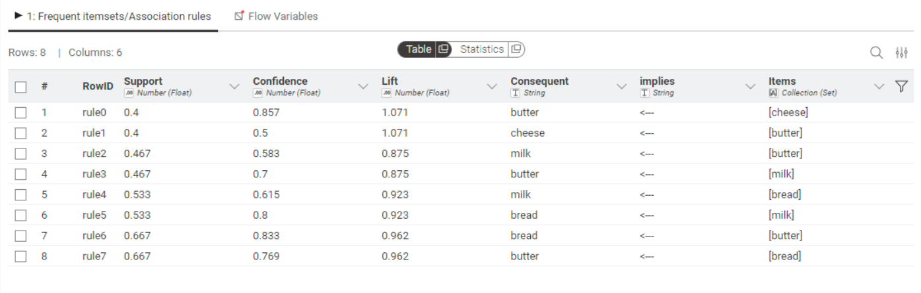

**3) Weka**

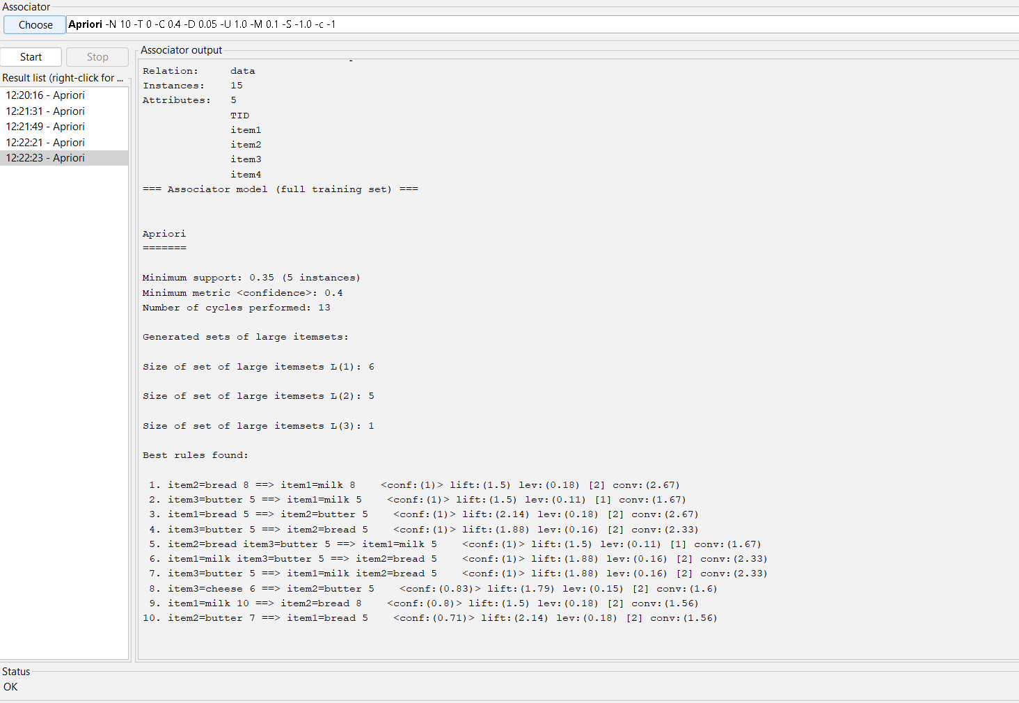

**Aim :**To calculate and analyze the correlation between different items or entities in a dataset to determine the strength and direction of their relationship.

**1) Using Program**

**Code :**import pandas as pd

import math

df = pd.read_csv('data.csv')

item_cols = [col for col in df.columns if col != 'TID']

pearson_results = []

for i in range(len(item_cols)):

    for j in range(i+1, len(item_cols)):

        col1 = item_cols[i]

        col2 = item_cols[j]

        x = df[col1].values

        y = df[col2].values

        n = len(x)

        x_mean = sum(x) / n

        y_mean = sum(y) / n

        numerator = sum((xi - x_mean) * (yi - y_mean) for xi, yi in zip(x, y))

        denominator = math.sqrt(

            sum((xi - x_mean) ** 2 for xi in x) * sum((yi - y_mean) ** 2 for yi in y)

        )

        r = numerator / denominator if denominator != 0 else float('nan')

        pearson_results.append({

            'Item 1': col1,

            'Item 2': col2,

            'Pearson Correlation': r

        })

        print(f"Pearson correlation between {col1} and {col2}: {r}")

pearson_df = pd.DataFrame(pearson_results)

pearson_df.to_csv('pearson_correlation_output.csv', index=False)

**Input:**

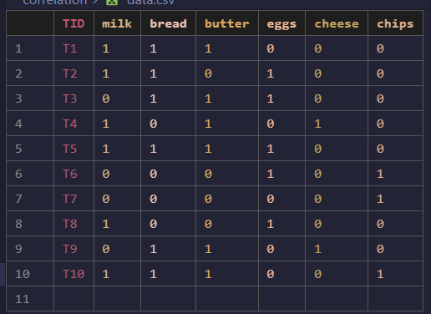

**Output:  
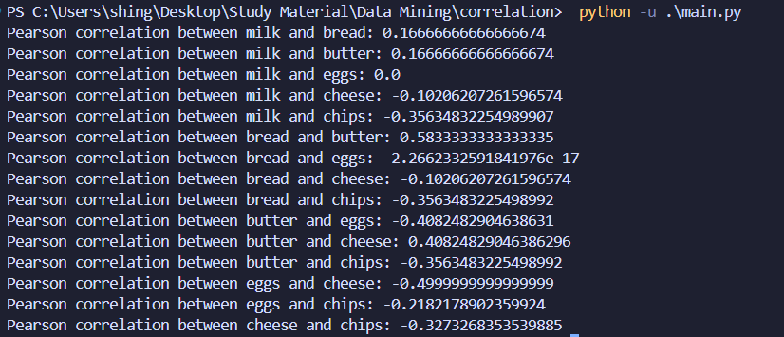  
  
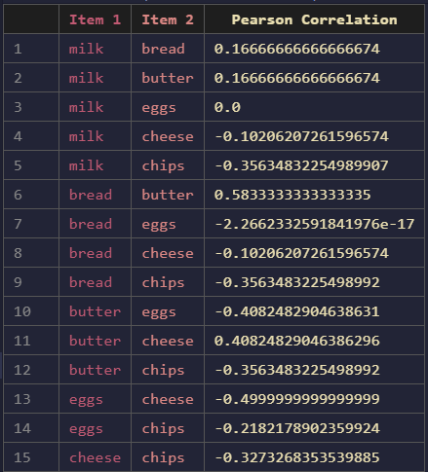**

**2) Using Knime**

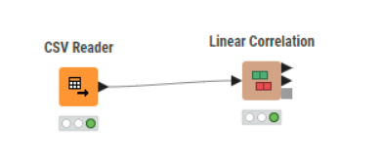

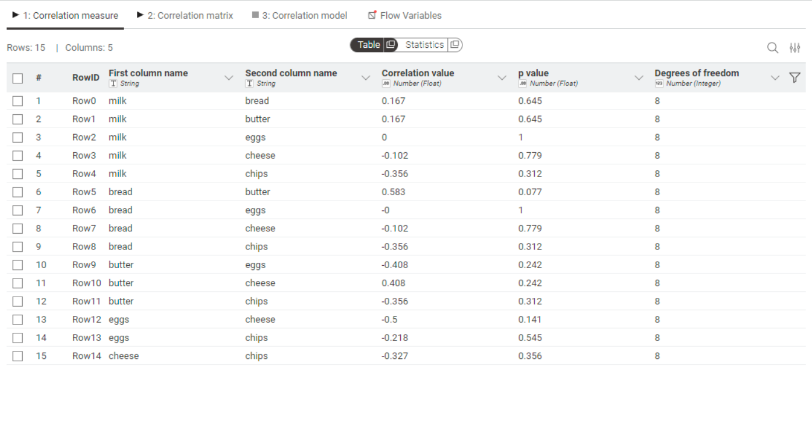

**Assignment 8 : Implement different types of clustering**

**Aim :**To study and implement different clustering techniques used in data mining.

**1) Using Program**

**Code :**

**K-means**import random

import pandas as pd

path = "data.csv"

out_path = "k-means.csv"

random.seed(42)

df = pd.read_csv(path)

num_cols = list(df.select_dtypes(include="number").columns)

if not num_cols:

    raise SystemExit("No numeric columns found in the CSV.")

df_num = df[num_cols].dropna()

rows = df_num.values.tolist()

indexes = df_num.index.tolist()

try:

    k = int(input("Enter number of clusters k: ").strip())

except Exception:

    k = 3

if k < 1:

    k = 1

if k > len(rows):

    k = len(rows)

def euclid(a, b):

    return sum((x - y) ** 2 for x, y in zip(a, b)) ** 0.5

def write_step_matrix(step_name, rows_data, centers, csv_path):

    labels = [f"p{i+1}" for i in range(len(rows_data))]

    matrix = []

    for i in range(len(rows_data)):

        row_vals = []

        for j in range(len(rows_data)):

            if i == j:

                row_vals.append(0.0)

            elif i > j:

                row_vals.append(euclid(rows_data[i], rows_data[j]))

            else:

                row_vals.append("")

        matrix.append(row_vals)

    with open(csv_path, "a", newline="") as f:

        f.write(f"Step:,{step_name}\n")

        f.write("," + ",".join(labels) + "\n")

        for i in range(len(rows_data)):

            values = [

                (f"{v:.4f}" if isinstance(v, float) else str(v)) for v in matrix[i]

            ]

            f.write(labels[i] + "," + ",".join(values) + "\n")

        for ci, c in enumerate(centers):

            dists = [f"{euclid(c, rows_data[j]):.4f}" for j in range(

                len(rows_data))]

            f.write(f"c{ci+1}," + ",".join(dists) + "\n")

        f.write("\n")

def mean_point(points):

    n = len(points)

    dim = len(points[0])

    return [sum(p[i] for p in points) / n for i in range(dim)]

centroids = [list(rows[i]) for i in random.sample(range(len(rows)), k)]

print("Initial centers:")

for idx, c in enumerate(centroids):

    print(f" Center {idx}: " + ", ".join(f"{x:.4f}" for x in c))

steps_csv_path = "k-means-out.csv"

open(steps_csv_path, "w").close()

write_step_matrix("init", rows, centroids, steps_csv_path)

max_iters = 1000

for step in range(max_iters):

    clusters = [[] for _ in range(k)]

    labels = []

    all_dists = []

    for row_idx, x in enumerate(rows):

        dists = [euclid(x, c) for c in centroids]

        idx = dists.index(min(dists))

        labels.append(idx)

        clusters[idx].append(x)

        all_dists.append(dists)

    write_step_matrix(f"iter_{step}", rows, centroids, steps_csv_path)

    new_centroids = []

    changed = False

    for i in range(k):

        if clusters[i]:

            new_c = mean_point(clusters[i])

        else:

            new_c = list(rows[random.randrange(len(rows))])

        new_centroids.append(new_c)

        if not changed:

            for a, b in zip(new_c, centroids[i]):

                if abs(a - b) > 1e-8:

                    changed = True

                    break

    centroids = new_centroids

    if not changed:

        break

counts = [labels.count(i) for i in range(k)]

df_out = df.copy()

df_out["cluster"] = pd.NA

for idx, lbl in zip(indexes, labels):

    df_out.at[idx, "cluster"] = int(lbl)

df_out.to_csv(out_path, index=False)

print("\nFinal cluster sizes:", counts)

print("Final centroids:")

for i, c in enumerate(centroids):

    print(f" C{i}: " + ", ".join(f"{x:.4f}" for x in c))

**DBSCAN**

import pandas as pd

import matplotlib.pyplot as plt

import itertools

DATA_PATH = "data.csv"

OUT_PATH = "dbscan.csv"

def dist(a, b):

    return sum((x - y) ** 2 for x, y in zip(a, b))**0.5

def region_query(rows, point_idx, eps2):

    p = rows[point_idx]

    neighbors = []

    for j, q in enumerate(rows):

        if dist(p, q) <= eps2:

            neighbors.append(j)

    return neighbors

def dbscan(rows, eps, min_samples):

    n = len(rows)

    labels = [None] * n

    cluster_id = 0

    eps2 = eps * eps

    for i in range(n):

        if labels[i] is not None:

            continue

        neighbors = region_query(rows, i, eps2)

        if len(neighbors) < min_samples:

            labels[i] = -1

            continue

        labels[i] = cluster_id

        seeds = neighbors.copy()

        k = 0

        while k < len(seeds):

            j = seeds[k]

            if labels[j] is None:

                labels[j] = cluster_id

                j_neighbors = region_query(rows, j, eps2)

                if len(j_neighbors) >= min_samples:

                    for nb in j_neighbors:

                        if nb not in seeds:

                            seeds.append(nb)

            elif labels[j] == -1:

                labels[j] = cluster_id

            k += 1

        cluster_id += 1

    return labels

def main():

    df = pd.read_csv(DATA_PATH)

    num_cols = list(df.select_dtypes(include="number").columns)

    if not num_cols:

        raise SystemExit("No numeric columns found in the CSV.")

    df_num = df[num_cols].dropna()

    rows = df_num.values.tolist()

    indexes = df_num.index.tolist()

    try:

        eps = float(input("Enter neighborhood radius eps : ").strip())

    except Exception:

        eps = 0.5

    try:

        min_samples = int(input("Enter min_samples : ").strip())

    except Exception:

        min_samples = 5

    if eps <= 0:

        eps = 0.5

    if min_samples < 1:

        min_samples = 1

    labels = dbscan(rows, eps, min_samples)

    df_out = df.copy()

    df_out["cluster"] = pd.NA

    for idx, lbl in zip(indexes, labels):

        df_out.at[idx, "cluster"] = int(lbl)

    df_out.to_csv(OUT_PATH, index=False)

    n_noise = sum(1 for l in labels if l == -1)

    cluster_ids = sorted(set(l for l in labels if l is not None and l >= 0))

    counts = {cid: labels.count(cid) for cid in cluster_ids}

    print(f"\nDBSCAN results (eps={eps}, min_samples={min_samples}):")

    print("Clusters and sizes:")

    for cid in cluster_ids:

        print(f"  Cluster {cid}: {counts[cid]} points")

    print(f"  Noise: {n_noise} points")

if __name__ == "__main__":

    main()

**Heirarchial Single Linkage**

import pandas as pd

path = "data.csv"

out_path = "heirarchial-single.csv"

matrix_path = "heirarchial-single-steps.csv"

df = pd.read_csv(path)

num_cols = list(df.select_dtypes(include="number").columns)

if not num_cols:

    raise SystemExit("No numeric columns found in the CSV.")

df_num = df[num_cols].dropna()

rows = df_num.values.tolist()

indexes = df_num.index.tolist()

def dist(a, b):

    return sum((x - y) ** 2 for x, y in zip(a, b)) ** 0.5

def write_step_matrix(step_name, clusters_data, csv_path):

    labels = ["|".join(f"p{i+1}" for i in sorted(cluster)) for cluster in clusters_data]

    n = len(clusters_data)

    matrix = []

    for i in range(n):

        row_vals = []

        for j in range(n):

            if i == j:

                row_vals.append(0.0)

            elif i > j:

                min_d = float("inf")

                for a in clusters_data[i]:

                    for b in clusters_data[j]:

                        d = dist(rows[a], rows[b])

                        if d < min_d:

                            min_d = d

                row_vals.append(min_d)

            else:

                row_vals.append("")

        matrix.append(row_vals)

    with open(csv_path, "a", newline="") as f:

        f.write(f"Grouping:,{step_name}\n")

        f.write("," + ",".join(labels) + "\n")

        for i in range(n):

            values = [(f"{v:.4f}" if isinstance(v, float) else str(v)) for v in matrix[i]]

            f.write(labels[i] + "," + ",".join(values) + "\n")

        f.write("\n")

clusters = [[i] for i in range(len(rows))]

open(matrix_path, "w").close()

write_step_matrix("initial", clusters, matrix_path)

labels_print = [f"p{i+1}" for i in range(len(rows))]

print("Grouping: initial")

for gi, g in enumerate(clusters):

    print(f"group{gi+1}: " + "|".join(labels_print[idx] for idx in g))

print()

def cluster_distance(c1, c2):

    m = float("inf")

    for i in c1:

        for j in c2:

            d = dist(rows[i], rows[j])

            if d < m:

                m = d

    return m

step_idx = 1

while len(clusters) > 1:

    best_i, best_j, best_d = None, None, float("inf")

    for i in range(len(clusters)):

        for j in range(i + 1, len(clusters)):

            d = cluster_distance(clusters[i], clusters[j])

            if d < best_d:

                best_d = d

                best_i, best_j = i, j

    merged = clusters[best_i] + clusters[best_j]

    new_clusters = []

    for t, c in enumerate(clusters):

        if t != best_i and t != best_j:

            new_clusters.append(c)

    new_clusters.append(merged)

    clusters = new_clusters

    write_step_matrix(f"grouping_{step_idx}", clusters, matrix_path)

    print(f"Grouping: grouping_{step_idx} (distance merged: {best_d:.4f})")

    for gi, g in enumerate(clusters):

        print(f"group{gi+1}: " + "|".join(labels_print[idx] for idx in g))

    print()

    step_idx += 1

labels = [None] * len(rows)

for cid, c in enumerate(clusters):

    for idx in c:

        labels[idx] = cid

df_out = df.copy()

df_out["cluster"] = pd.NA

for idx, lbl in zip(indexes, labels):

    df_out.at[idx, "cluster"] = int(lbl)

df_out.to_csv(out_path, index=False)

print("Final clusters:")

for gi, g in enumerate(clusters):

    print(f"cluster{gi}: " + "|".join(labels_print[idx] for idx in g))

**Heirarchial Complete Linkage**

import pandas as pd

path = "data.csv"

out_path = "heirarchial-complete.csv"

matrix_path = "heirarchial-complete-steps.csv"

df = pd.read_csv(path)

num_cols = list(df.select_dtypes(include="number").columns)

if not num_cols:

    raise SystemExit("No numeric columns found in the CSV.")

df_num = df[num_cols].dropna()

rows = df_num.values.tolist()

indexes = df_num.index.tolist()

def dist(a, b):

    return sum((x - y) ** 2 for x, y in zip(a, b)) ** 0.5

def write_step_matrix(step_name, clusters_data, csv_path):

    labels = ["|".join(f"p{i+1}" for i in sorted(cluster)) for cluster in clusters_data]

    n = len(clusters_data)

    matrix = []

    for i in range(n):

        row_vals = []

        for j in range(n):

            if i == j:

                row_vals.append(0.0)

            elif i > j:

                max_d = 0.0

                for a in clusters_data[i]:

                    for b in clusters_data[j]:

                        d = dist(rows[a], rows[b])

                        if d > max_d:

                            max_d = d

                row_vals.append(max_d)

            else:

                row_vals.append("")

        matrix.append(row_vals)

    with open(csv_path, "a", newline="") as f:

        f.write(f"Grouping:,{step_name}\n")

        f.write("," + ",".join(labels) + "\n")

        for i in range(n):

            values = [(f"{v:.4f}" if isinstance(v, float) else str(v)) for v in matrix[i]]

            f.write(labels[i] + "," + ",".join(values) + "\n")

        f.write("\n")

clusters = [[i] for i in range(len(rows))]

open(matrix_path, "w").close()

write_step_matrix("initial", clusters, matrix_path)

labels_print = [f"p{i+1}" for i in range(len(rows))]

print("Grouping: initial")

for gi, g in enumerate(clusters):

    print(f"group{gi+1}: " + "|".join(labels_print[idx] for idx in g))

def cluster_distance_complete(c1, c2):

    m = 0.0

    for i in c1:

        for j in c2:

            d = dist(rows[i], rows[j])

            if d > m:

                m = d

    return m

step_idx = 1

while len(clusters) > 1:

    best_i, best_j, best_d = None, None, -1.0

    for i in range(len(clusters)):

        for j in range(i + 1, len(clusters)):

            d = cluster_distance_complete(clusters[i], clusters[j])

            if d > best_d:

                best_d = d

                best_i, best_j = i, j

    merged = clusters[best_i] + clusters[best_j]

    new_clusters = []

    for t, c in enumerate(clusters):

        if t != best_i and t != best_j:

            new_clusters.append(c)

    new_clusters.append(merged)

    clusters = new_clusters

    write_step_matrix(f"grouping_{step_idx}", clusters, matrix_path)

    print(f"Grouping: grouping_{step_idx} (distance merged: {best_d:.4f})")

    for gi, g in enumerate(clusters):

        print(f"group{gi+1}: " + "|".join(labels_print[idx] for idx in g))

    print()

    step_idx += 1

labels = [None] * len(rows)

for cid, c in enumerate(clusters):

    for idx in c:

        labels[idx] = cid

df_out = df.copy()

df_out["cluster"] = pd.NA

for idx, lbl in zip(indexes, labels):

    df_out.at[idx, "cluster"] = int(lbl)

df_out.to_csv(out_path, index=False)

print("Final clusters:")

for gi, g in enumerate(clusters):

    print(f"cluster{gi}: " + "|".join(labels_print[idx] for idx in g))

**Heirarchial Average Linkage**  
import pandas as pd

path = "data.csv"

out_path = "heirarchial-average.csv"

matrix_path = "heirarchial-average-steps.csv"

df = pd.read_csv(path)

num_cols = list(df.select_dtypes(include="number").columns)

if not num_cols:

    raise SystemExit("No numeric columns found in the CSV.")

df_num = df[num_cols].dropna()

rows = df_num.values.tolist()

indexes = df_num.index.tolist()

def dist(a, b):

    return sum((x - y) ** 2 for x, y in zip(a, b)) ** 0.5

def average_linkage_distance(c1, c2):

    total = 0.0

    count = 0

    for i in c1:

        for j in c2:

            total += dist(rows[i], rows[j])

            count += 1

    return total / count if count > 0 else 0.0

def write_step_matrix(step_name, clusters_data, csv_path):

    labels = ["|".join(f"p{i+1}" for i in sorted(cluster)) for cluster in clusters_data]

    n = len(clusters_data)

    matrix = []

    for i in range(n):

        row_vals = []

        for j in range(n):

            if i == j:

                row_vals.append(0.0)

            elif i > j:

                d = average_linkage_distance(clusters_data[i], clusters_data[j])

                row_vals.append(d)

            else:

                row_vals.append("")

        matrix.append(row_vals)

    with open(csv_path, "a", newline="") as f:

        f.write(f"Grouping:,{step_name}\n")

        f.write("," + ",".join(labels) + "\n")

        for i in range(n):

            values = [(f"{v:.4f}" if isinstance(v, float) else str(v)) for v in matrix[i]]

            f.write(labels[i] + "," + ",".join(values) + "\n")

        f.write("\n")

clusters = [[i] for i in range(len(rows))]

open(matrix_path, "w").close()

write_step_matrix("initial", clusters, matrix_path)

labels_print = [f"p{i+1}" for i in range(len(rows))]

print("Grouping: initial")

for gi, g in enumerate(clusters):

    print(f"group{gi+1}: " + "|".join(labels_print[idx] for idx in g))

step_idx = 1

while len(clusters) > 1:

    best_i, best_j, best_d = None, None, float("inf")

    for i in range(len(clusters)):

        for j in range(i + 1, len(clusters)):

            d = average_linkage_distance(clusters[i], clusters[j])

            if d < best_d:

                best_d = d

                best_i, best_j = i, j

    merged = clusters[best_i] + clusters[best_j]

    new_clusters = []

    for t, c in enumerate(clusters):

        if t != best_i and t != best_j:

            new_clusters.append(c)

    new_clusters.append(merged)

    clusters = new_clusters

    write_step_matrix(f"grouping_{step_idx}", clusters, matrix_path)

    print(f"Grouping: grouping_{step_idx} (distance merged: {best_d:.4f})")

    for gi, g in enumerate(clusters):

        print(f"group{gi+1}: " + "|".join(labels_print[idx] for idx in g))

    print()

    step_idx += 1

labels = [None] * len(rows)

for cid, c in enumerate(clusters):

    for idx in c:

        labels[idx] = cid

df_out = df.copy()

df_out["cluster"] = pd.NA

for idx, lbl in zip(indexes, labels):

    df_out.at[idx, "cluster"] = int(lbl)

df_out.to_csv(out_path, index=False)

print("Final clusters:")

for gi, g in enumerate(clusters):

    print(f"cluster{gi}: " + "|".join(labels_print[idx] for idx in g))

**Input:**

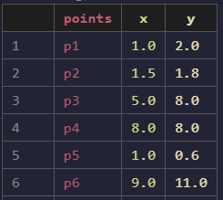

**Output:  
K-means   
  
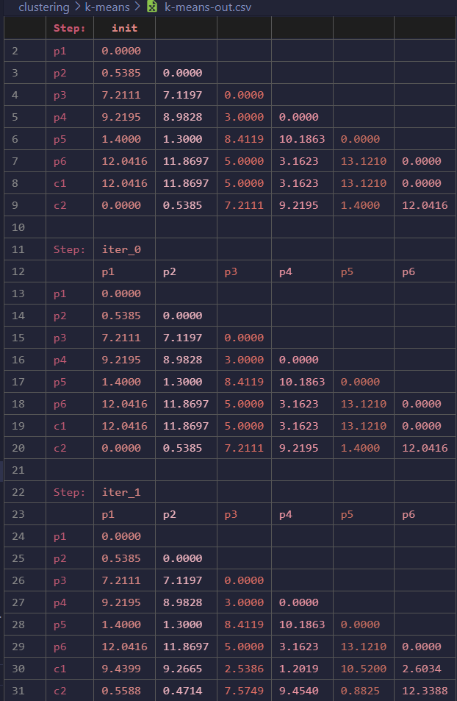**

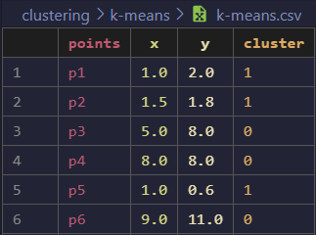

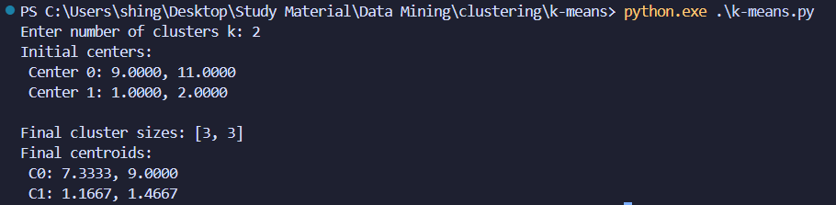

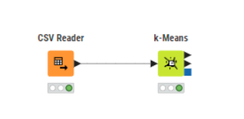

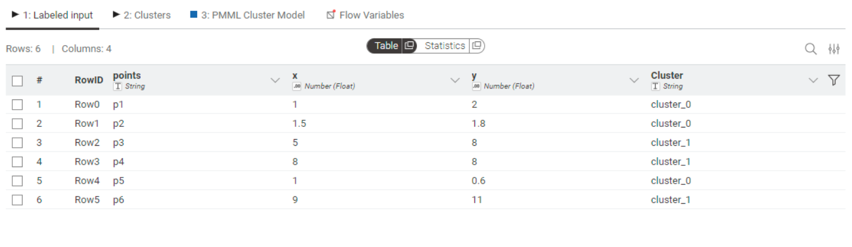

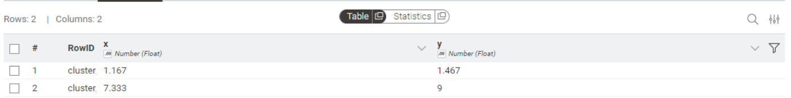

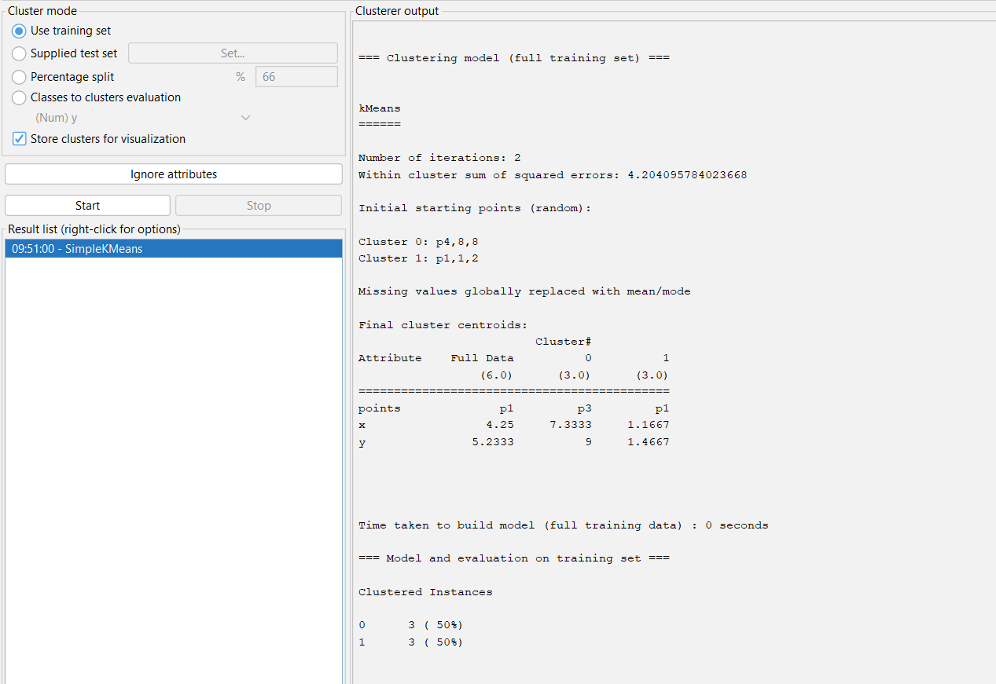

**DBSCAN  
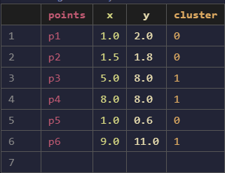  
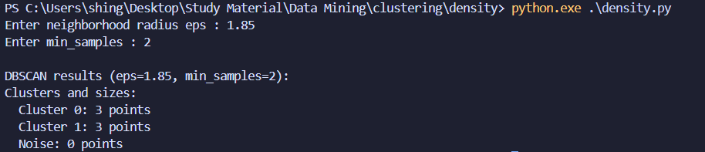**

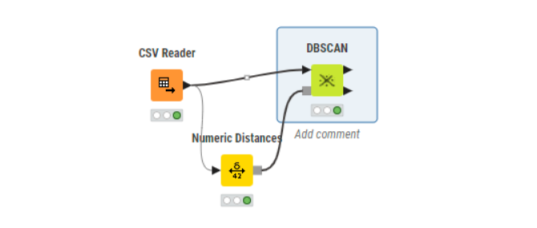

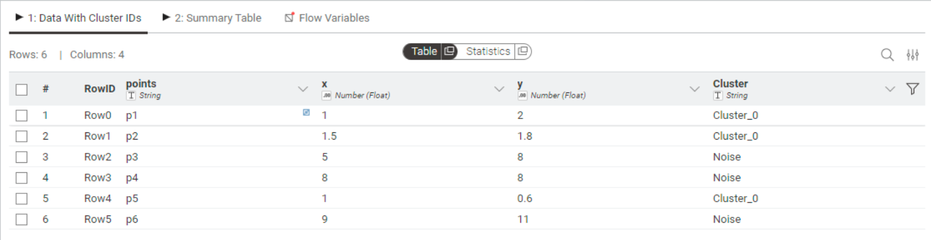

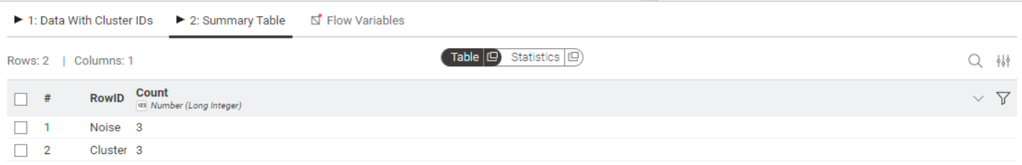

**Heirarchial :  
Single Linkage**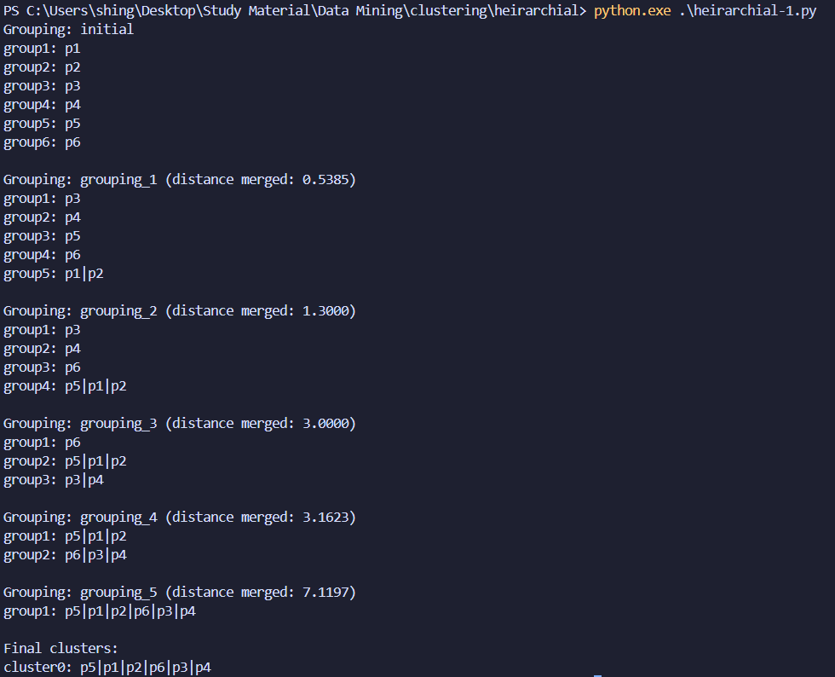 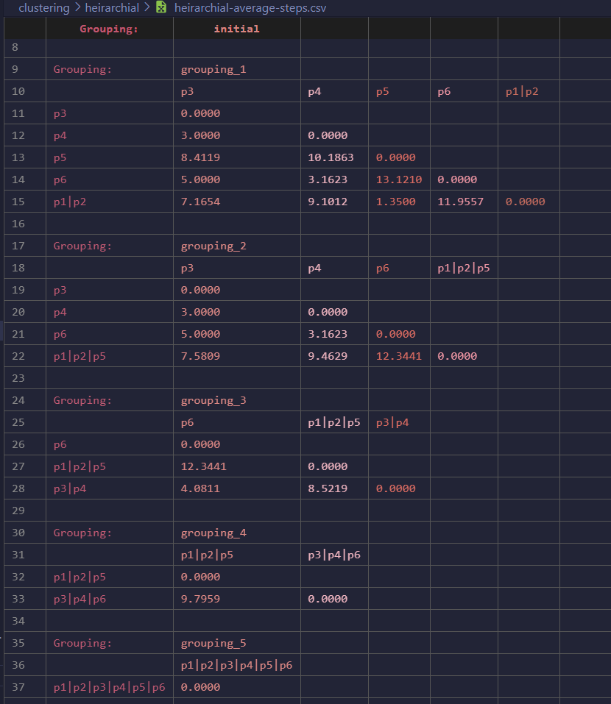

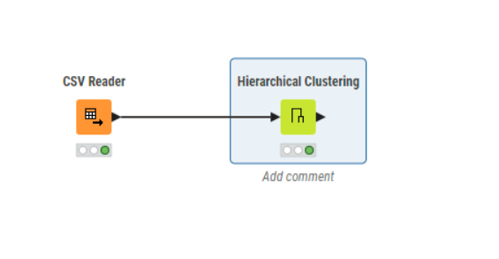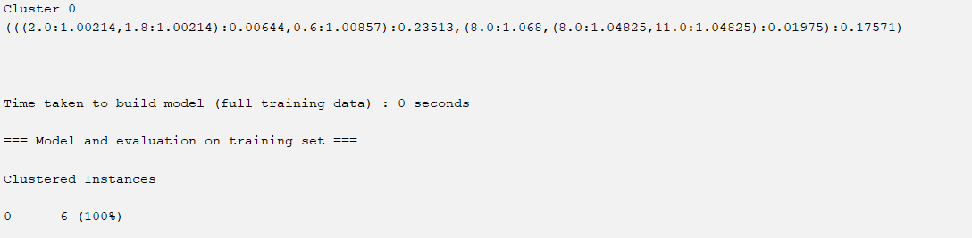

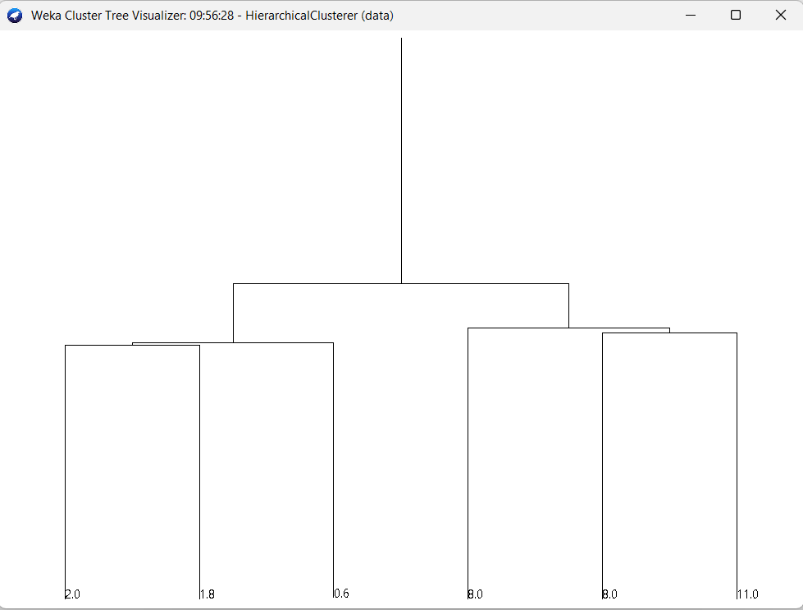

**Complete Linkage:  
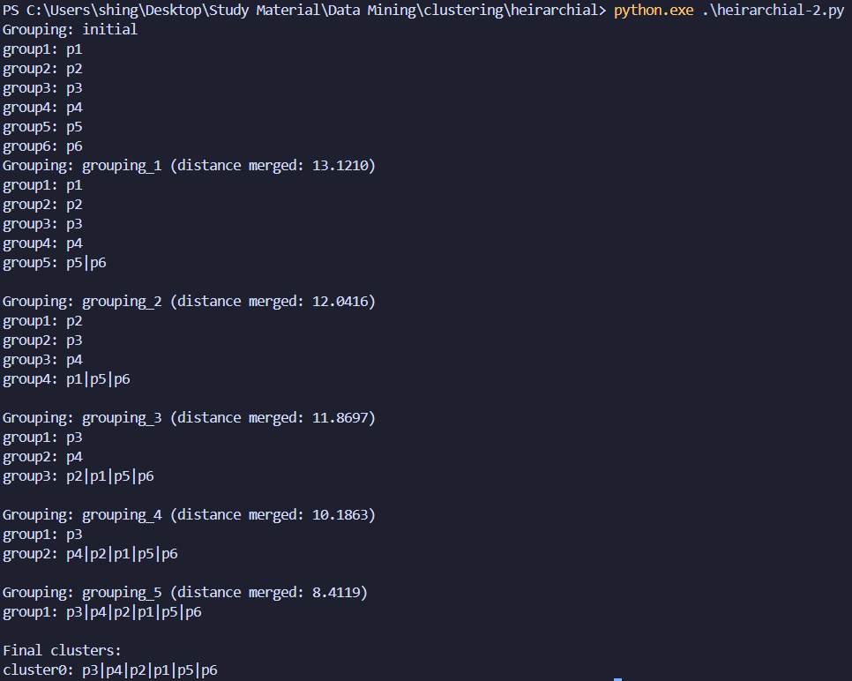  
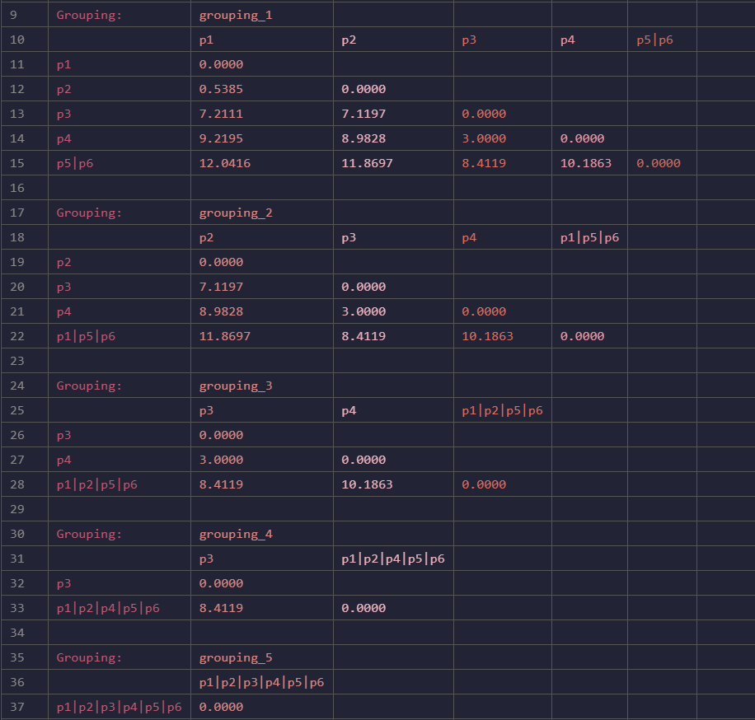**

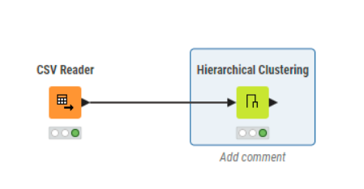

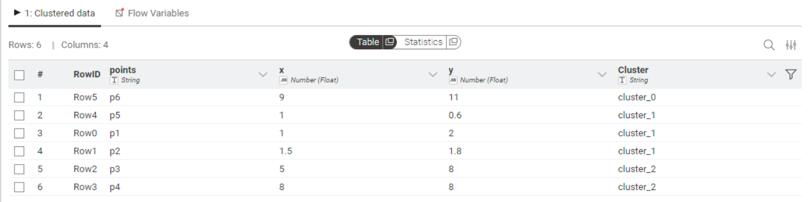

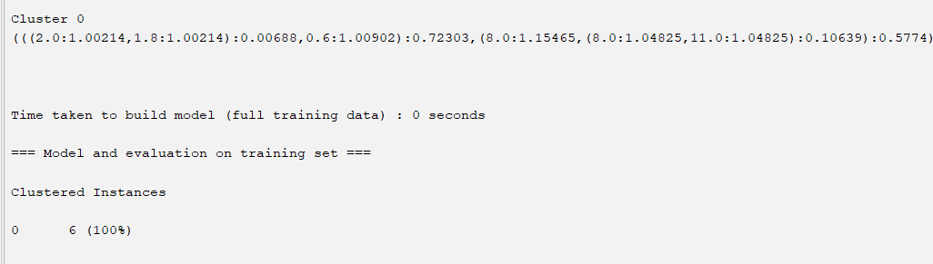

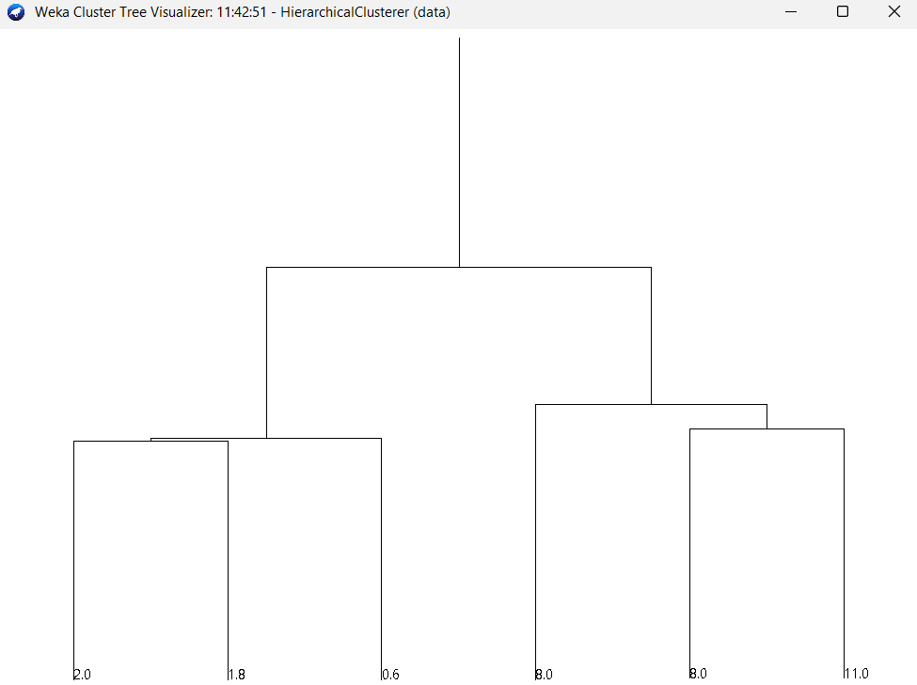

**Average Linkage :**

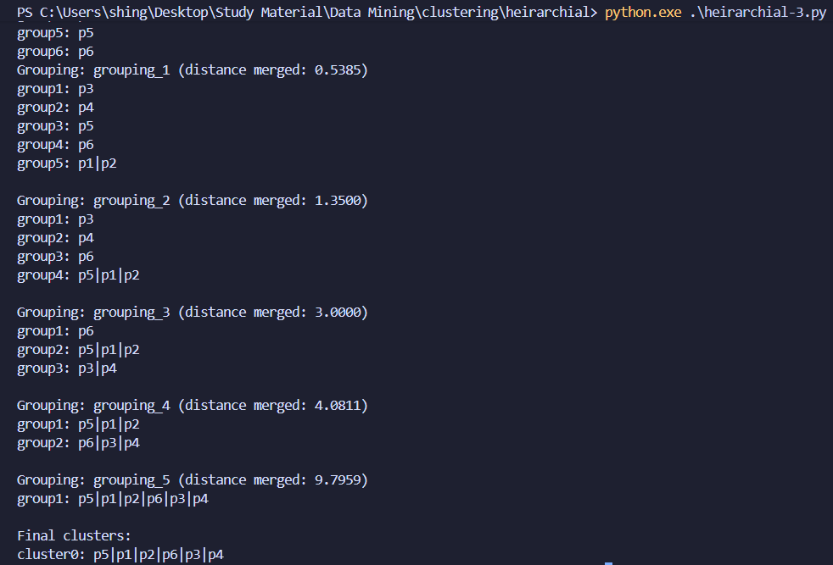

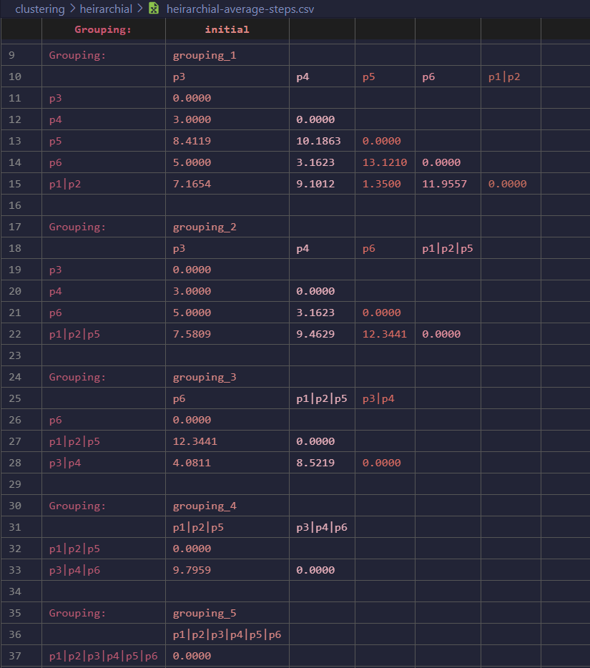

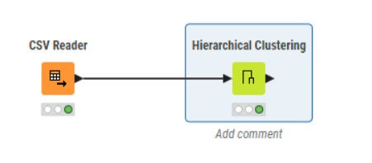

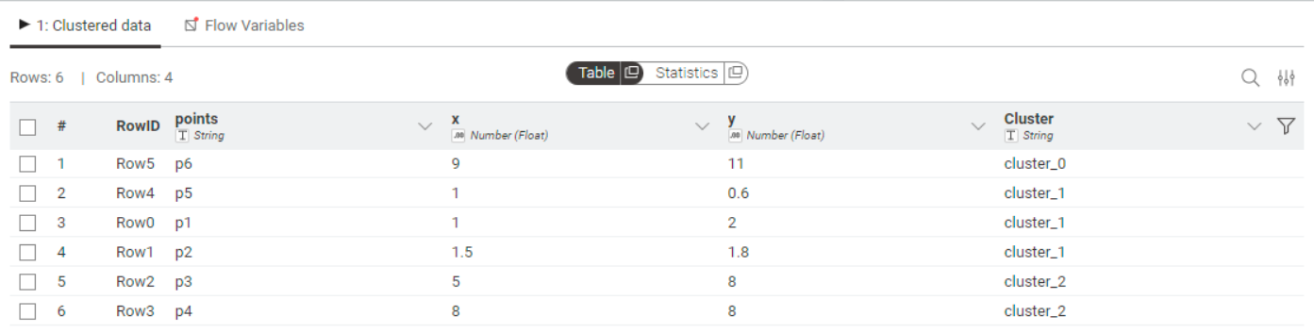

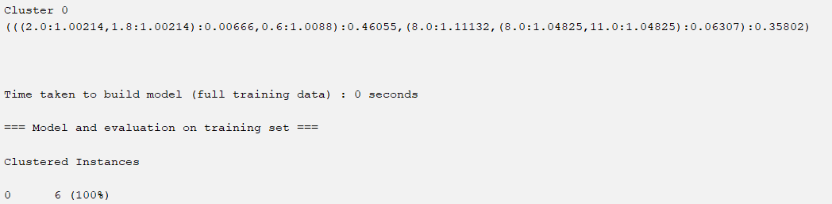

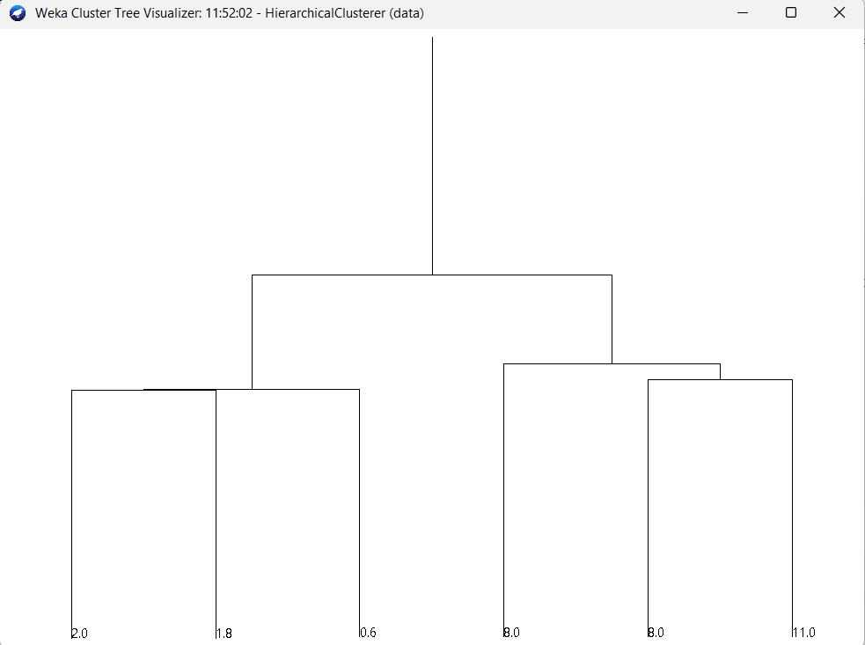

**Aim :**   
Attribute for classification . Write a program to find.   
a. Gain b. Gini Index   
For categorical and numerical values  
  
**1) Using Program**   
**Code :**   
import pandas as pd

import math

def read_data(filename):

    df = pd.read_csv(filename)

    return df

def entropy(series):

    values = series.value_counts(normalize=True)

    ent = -sum(p * math.log2(p) for p in values if p > 0)

    print(f"Entropy of {series.name}: {ent:.4f}")

    return ent

def gini_index(series):

    values = series.value_counts(normalize=True)

    gini = 1 - sum(p ** 2 for p in values)

    print(f"Gini index of {series.name}: {gini:.4f}")

    return gini

def info_gain(df, attr, target):

    total_entropy = entropy(df[target])

    weighted_entropy = 0

    for val, subset in df.groupby(attr):

        weight = len(subset) / len(df)

        ent = entropy(subset[target])

        weighted_entropy += weight * ent

        print(f"  {attr}={val}: weight={weight:.3f}, entropy={ent:.4f}")

    gain = total_entropy - weighted_entropy

    print(f"Information Gain for {attr}: {gain:.4f}")

    return gain

def gini_split(df, attr, target):

    weighted_gini = 0

    for val, subset in df.groupby(attr):

        weight = len(subset) / len(df)

        gini = gini_index(subset[target])

        weighted_gini += weight * gini

        print(f"  {attr}={val}: weight={weight:.3f}, gini={gini:.4f}")

    print(f"Gini Split for {attr}: {weighted_gini:.4f}")

    return weighted_gini

def main():

    target = input("Enter target (class) column name: ")

    df = read_data('data.csv')

    results = []

    for col in df.columns:

        if col == target:

            continue

        print(f"\n--- Attribute: {col} ---")

        gain = info_gain(df, col, target)

        gini = gini_split(df, col, target)

        results.append({"attribute": col, "gain": gain, "gini": gini})

    out_df = pd.DataFrame(results)

    out_df.to_csv("gain_gini_output.csv", index=False)

    print("\nResults saved to gain_gini_output.csv")

    print(out_df)

if __name__ == "__main__":

    main()

**Input :   
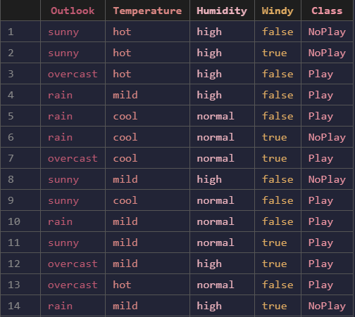**

**Ouput:**

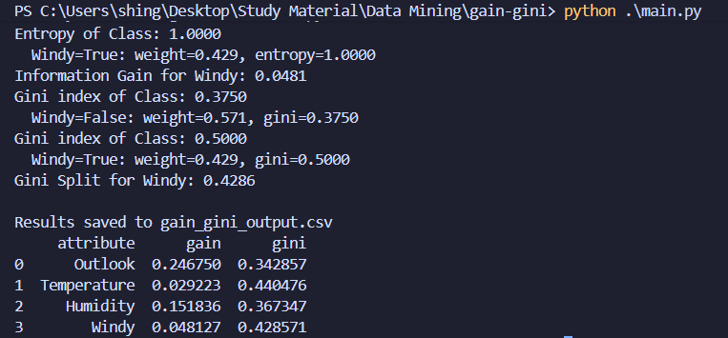

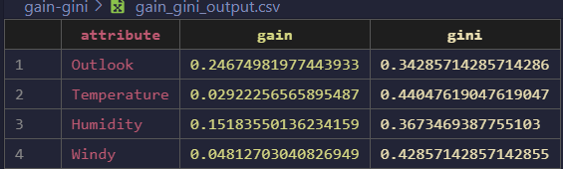

**2) Using Knime  
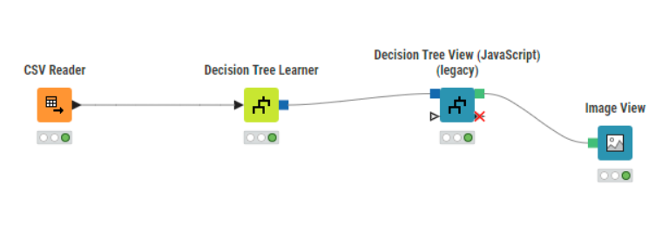  
  
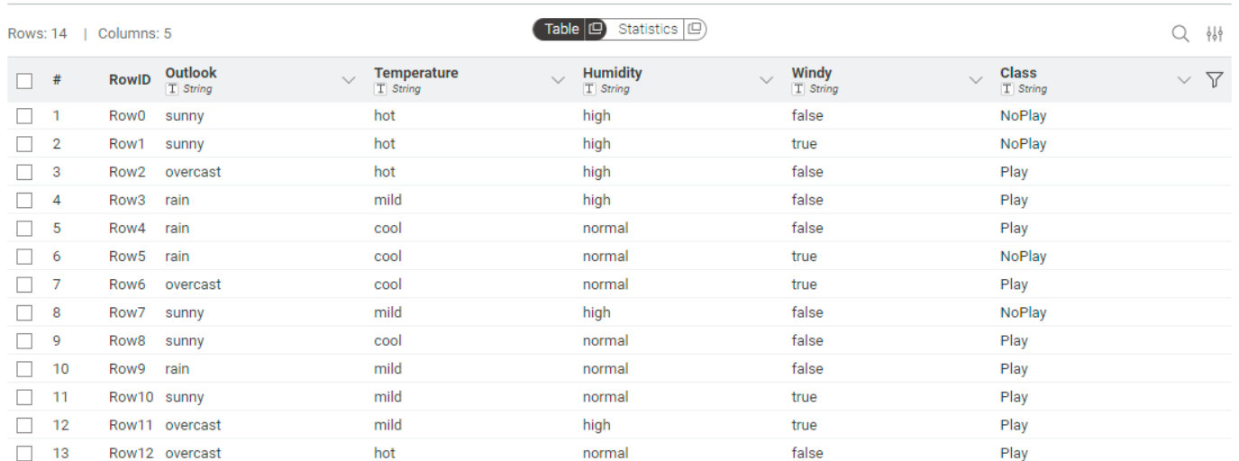  
  
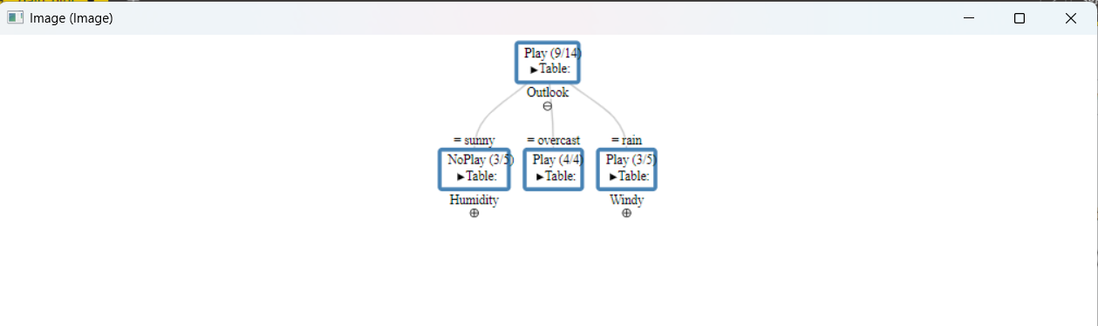**

**Weka :**

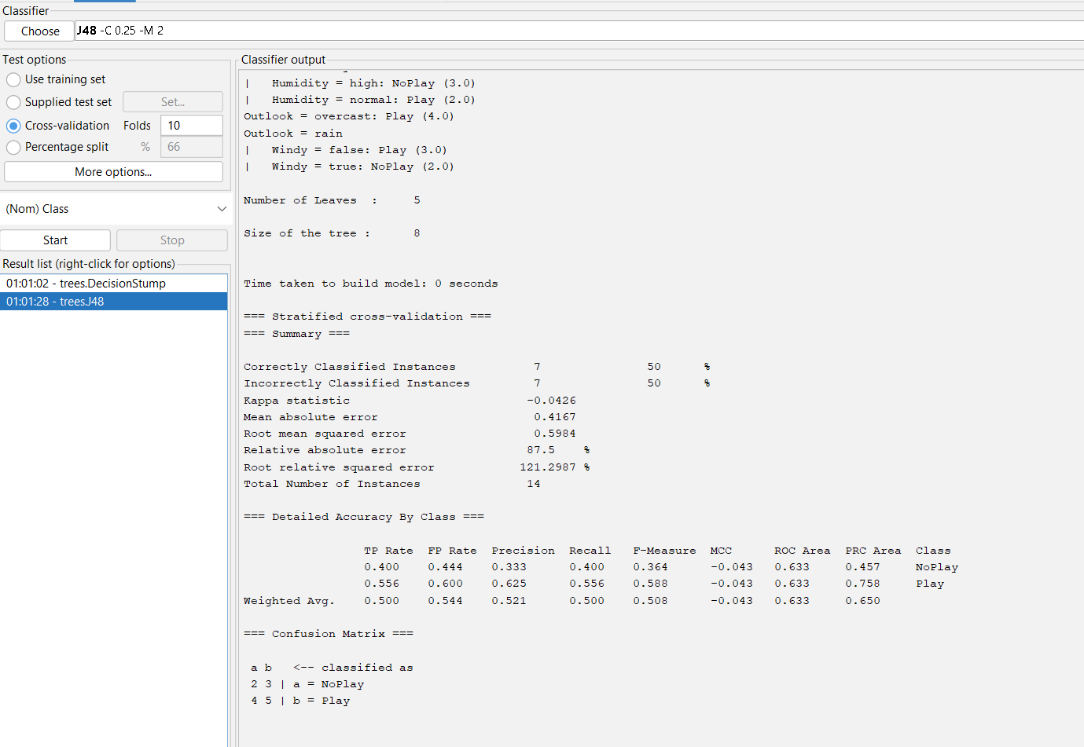

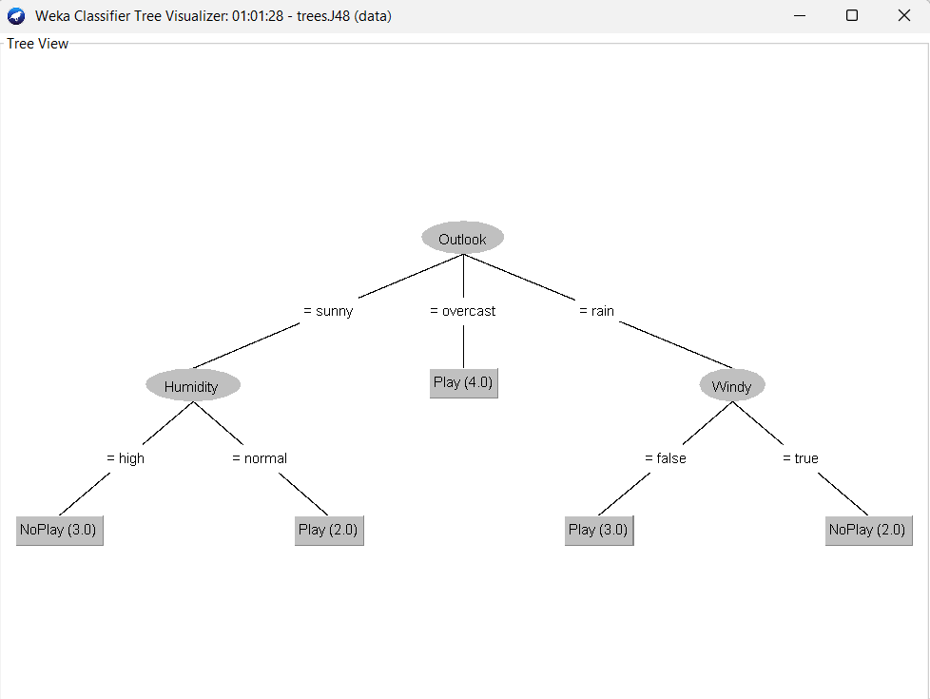

**Aim:**Write a program for bayes’ classification.

**1) Using Program  
Code :**import pandas as pd

def read_data(filename):

    return pd.read_csv(filename)

def normalize(df):

    df2 = df.copy()

    for col in df2.columns:

        df2[col] = df2[col].astype(str).str.lower().str.strip()

    return df2

def main():

    df = read_data("data.csv")

    df = normalize(df)

    df.columns = [c.lower() for c in df.columns]

    print("Available columns:", ", ".join(df.columns))

    target_col = input("\nEnter target (class) column name: ").strip().lower()

    feature_cols = [c for c in df.columns if c != target_col]

    total_rows = len(df)

    class_counts = df[target_col].value_counts().to_dict()

    base_prob = {cls: count / total_rows for cls, count in class_counts.items()}

    print("\nStep 1: Base Probability (P(Class))")

    for cls, count in class_counts.items():

        print(f"P({cls}) = {count}/{total_rows} = {base_prob[cls]:.3f}")

    print("\nStep 2: Enter new case")

    new_case = {}

    for col in feature_cols:

        val = input(f"  {col}: ").strip().lower()

        new_case[col] = val

    print("\nNew Case:")

    for k, v in new_case.items():

        print(f"  {k.capitalize()} = {v}")

    print("\nStep 3: Feature Probabilities P(feature=value | class)")

    feature_probs = {}

    for cls in df[target_col].unique():

        subset = df[df[target_col] == cls]

        total_in_class = len(subset)

        feature_probs[cls] = {}

        print(f"\nFor class = {cls} (Total = {total_in_class})")

        for feature, value in new_case.items():

            count_match = (subset[feature] == value).sum()

            prob = count_match / total_in_class if total_in_class > 0 else 0

            feature_probs[cls][feature] = prob

            print(f"P({feature}={value} | {cls}) = {count_match}/{total_in_class} = {prob:.3f}")

    print("\nStep 4: Final Probability (Base × All Features)")

    final_prob = {}

    for cls in feature_probs:

        product = 1

        for feature, prob in feature_probs[cls].items():

            product *= prob

        final_prob[cls] = base_prob[cls] * product

        print(f"P({cls}) × Π P(feature|{cls}) = {base_prob[cls]:.3f} × {product:.6f} = {final_prob[cls]:.6f}")

    print("\nStep 5: Compare Final Probabilities")

    for cls, prob in final_prob.items():

        print(f"Final probability for {cls}: {prob:.6f}")

    predicted = max(final_prob, key=final_prob.get)

    print(f"\nPredicted Class for the new case: {predicted.capitalize()}")

    output = {**new_case, "Predicted_Class": predicted}

    pd.DataFrame([output]).to_csv("bayes_output.csv", index=False)

    print("\nResult saved to 'bayes_output.csv'.")

if __name__ == "__main__":

    main()

**Input:  
**

**Output:  
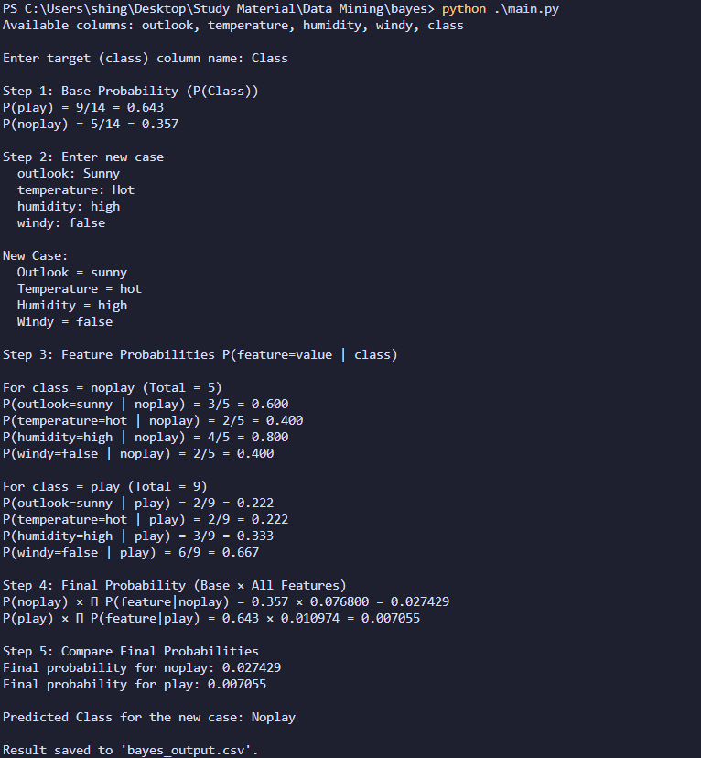**

**2) Knime   
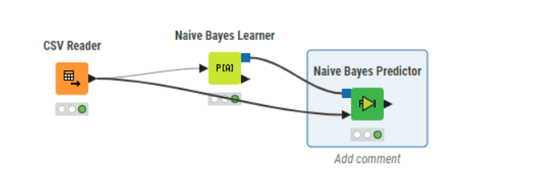  
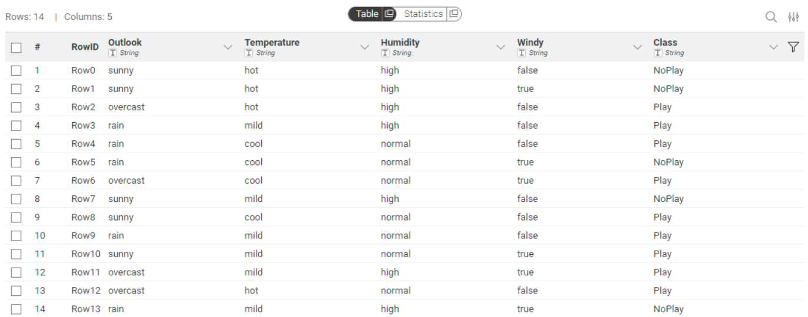  
  
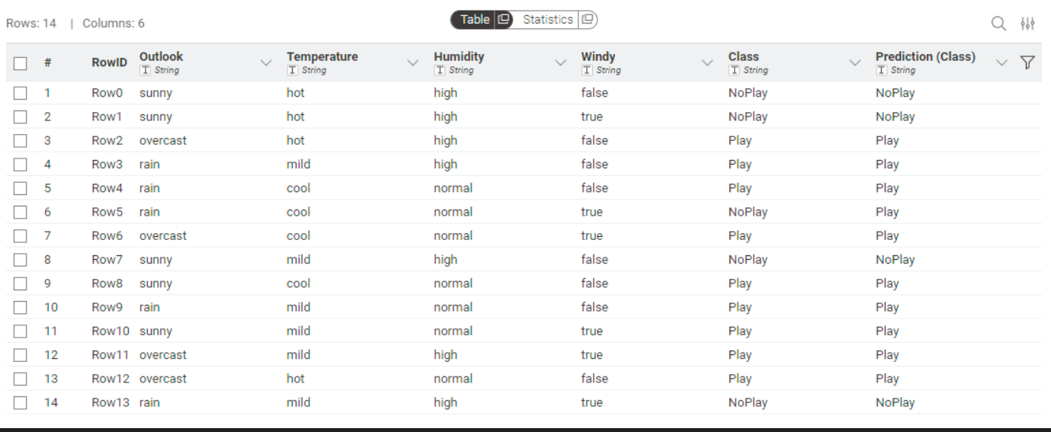**

**3) Weka  
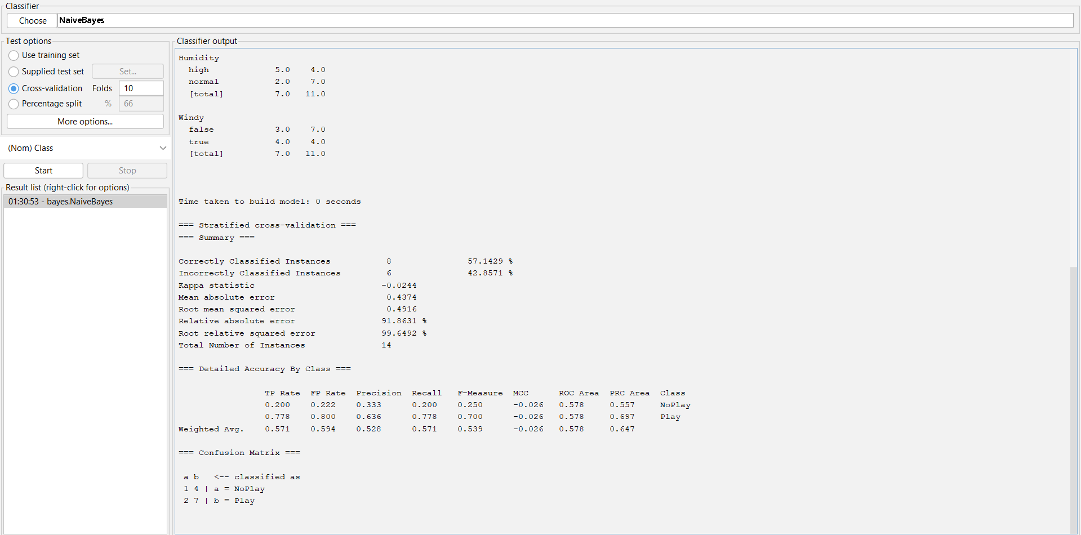**

**Aim:**Write a program to find linear regression coefficents

**1) Using Program  
Code :**import pandas as pd

def read_data(filename):

    df = pd.read_csv(filename)

    return df

def linear_regression(x, y):

    n = len(x)

    mean_x = sum(x) / n

    mean_y = sum(y) / n

    print(f"Mean of X: {mean_x:.4f}")

    print(f"Mean of Y: {mean_y:.4f}")

    num = sum((xi - mean_x) * (yi - mean_y) for xi, yi in zip(x, y))

    den = sum((xi - mean_x) ** 2 for xi in x)

    print(f"Numerator (Σ(xi - x̄)(yi - ȳ)): {num:.4f}")

    print(f"Denominator (Σ(xi - x̄)^2): {den:.4f}")

    slope = num / den if den != 0 else 0

    intercept = mean_y - slope * mean_x

    print(f"Slope (b1): {slope:.4f}")

    print(f"Intercept (b0): {intercept:.4f}")

    return slope, intercept

def main():

    df = read_data('data.csv')

    x_col = input("Enter independent variable (X) column name: ")

    y_col = input("Enter dependent variable (Y) column name: ")

    x = df[x_col].astype(float).tolist()

    y = df[y_col].astype(float).tolist()

    slope, intercept = linear_regression(x, y)

    print(f"\nRegression equation: {y_col} = {intercept:.4f} + {slope:.4f}*{x_col}")

    out_df = pd.DataFrame({

        x_col: x,

        y_col: y,

        'Predicted': [intercept + slope * xi for xi in x]

    })

    out_df.to_csv('linear_regression_output.csv', index=False)

    print("\nResults saved to linear_regression_output.csv")

if __name__ == "__main__":

    main()

**Input:  
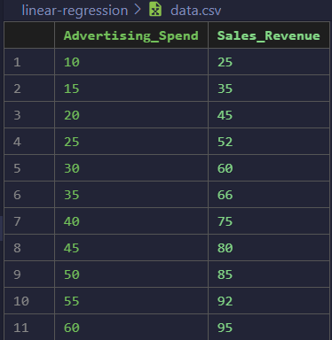**

**Output:**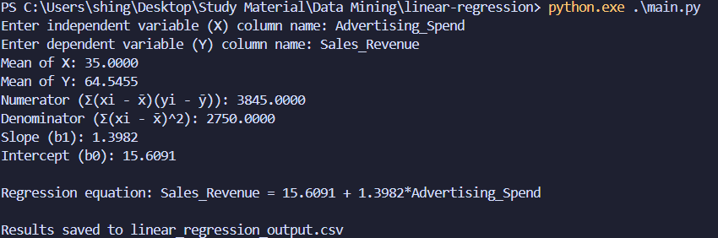 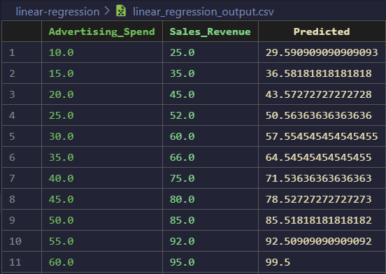

**2) Knime  
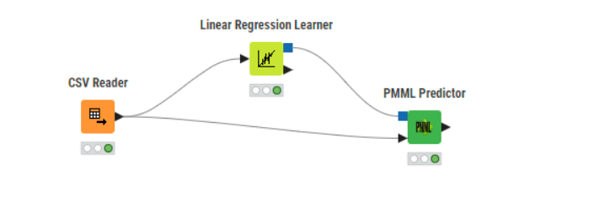**

**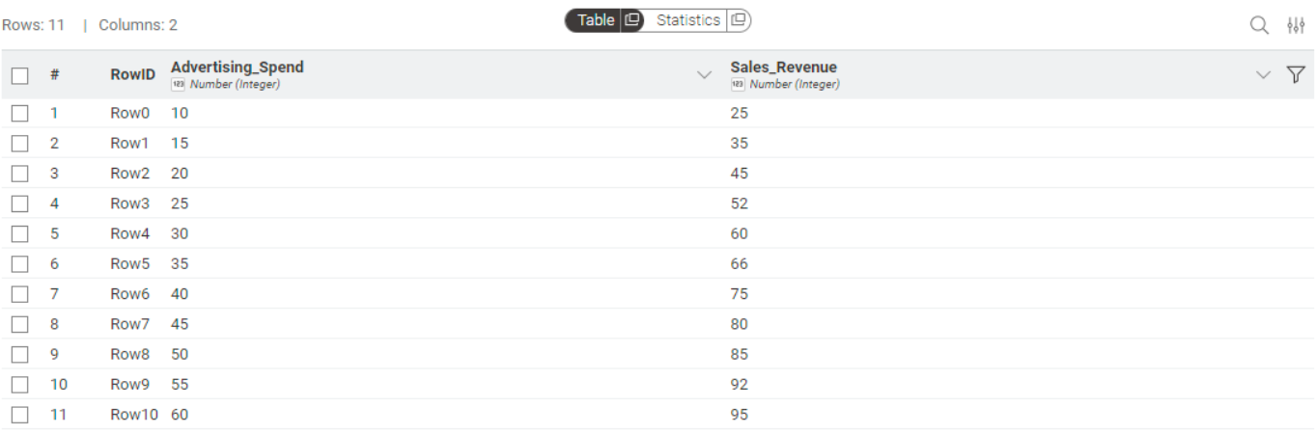  
  
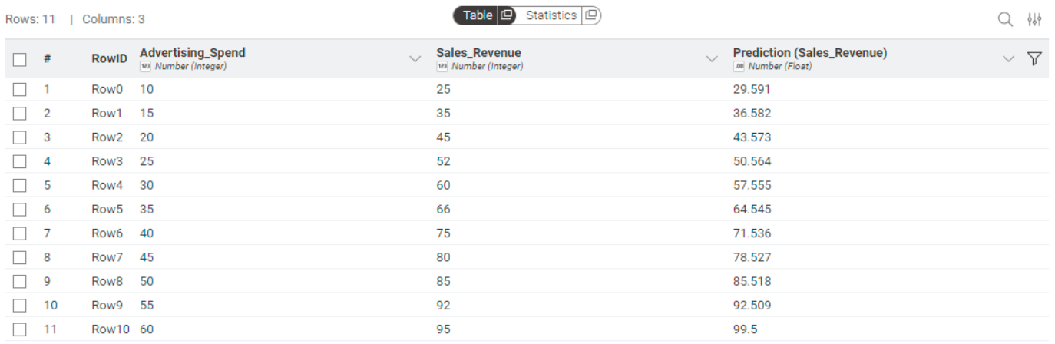**

**3) Weka  
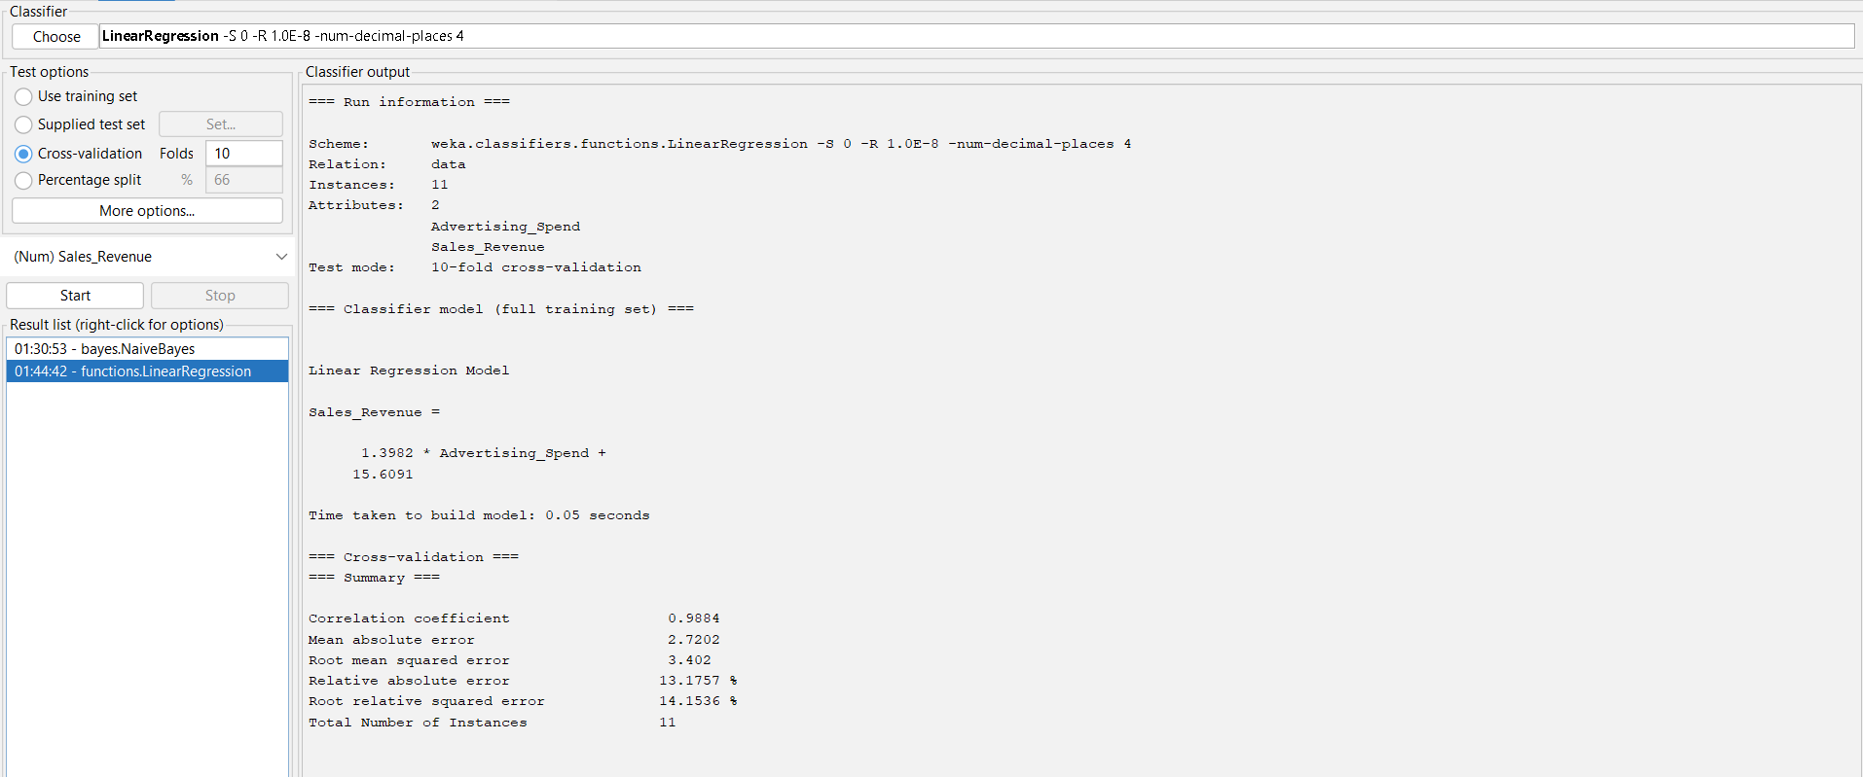**

**Aim:**Write a program to implement image segmentation using k-means clustering

**Code:**

import numpy as np

from PIL import Image

def read_image(filename):

    img = Image.open(filename)

    img = img.convert('RGB')

    data = np.array(img)

    print(f"Image loaded: {filename}, shape: {data.shape}")

    return img, data

def flatten_image(data):

    w, h, c = data.shape

    flat = data.reshape((w * h, c))

    return flat

def kmeans(X, k, max_iters=10):

    np.random.seed(42)

    idx = np.random.choice(len(X), k, replace=False)

    centers = X[idx]

    for it in range(max_iters):

        dists = np.linalg.norm(X[:, None] - centers[None, :], axis=2)

        labels = np.argmin(dists, axis=1)

        new_centers = np.array([X[labels == i].mean(axis=0) if np.any(labels == i) else centers[i] for i in range(k)])

        if np.allclose(centers, new_centers):

            print(f"Converged at iteration {it}")

            break

        centers = new_centers

    return labels, centers

def recreate_image(labels, centers, shape):

    seg_data = centers[labels].astype(np.uint8)

    seg_img = seg_data.reshape(shape)

    return seg_img

def main():

    img_file = input("Enter image filename: ")

    k = int(input("Enter number of clusters (k): "))

    img, data = read_image(img_file)

    flat = flatten_image(data)

    labels, centers = kmeans(flat, k)

    seg_img = recreate_image(labels, centers, data.shape)

    out_img = Image.fromarray(seg_img)

    out_img.save('output_kmeans.jpg')

    print("Segmented image saved as output_kmeans.jpg")

if __name__ == "__main__":

    main()

**Input:  
**

**Ouput:**

